NOTICES

ST. STEPHEN’S CHAPEL The Family Flower for June is given by Pam Storey in loving memory of her husband, Michael.

KITCHEN APPEAL You will see posters and a flyer you have been given about our Kitchen Appeal. Anyone who has been in our kitchen can see how much it needs improvement. We want to future proof our new kitchen so it is ready for whatever St Andrew’s provides in the future from café style tea and coffee to full meals on a regular or occasional basis. We aim to replace the kitchen in August. Please give generously.


SUMMER PICNIC Join us on the field any time after the 10am service on Sunday 28th June on the field. Bring your own food and drink but there will also be burgers and ice creams if the weather is hot. There will be live music from Groove Alchemy, who will provide a great atmosphere at the picnic, a bouncy castle and a play area for little ones. Just sign up to give us an idea of numbers; the cost will be £2 each.

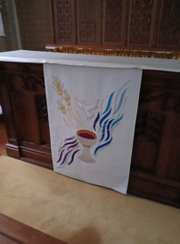
ALTAR FALL There is a new Altar Fall on the Altar in St Stephen's Chapel, which was designed and made by Julia Hemingray, who made our other new pieces. As before, if you would like to make a donation towards the cost in memory of a loved one or to celebrate a special anniversary or occasion, please speak to me or message on 07889 249500. Many thanks Wendy Godwin

FILING CABINET Do you have one you no longer use? If so we need one to store all our Children’s Church materials. Please let Barbara know if you can help.

bank details for one-off payments and gifts -
PCC of St Andrew's Roxbourne Parish
Sort code: 40-11-58 Acc No: 20404810
Please note this is not the account for regular Stewardship Giving - please see Wendy Godwin or Peter Sage for those details (Tel: 07889 249500)

In June, let us pray for sports to be an instrument of peace, encounter and dialogue among cultures and nations; may they promote the values of respect, solidarity and personal growth.
S^{T} ANDREW'S CHURCH, ROXBOURNE
 | 89 Malvern Avenue Harrow HA2 9ER.  020 8422 3633 www.standrewsroxbourne.org.uk  Registered Charity No. 1131727 | 

Star Link

SUNDAY, 21st JUNE TRINITY 3
Roxbournestandrews



8.00 am: Holy Communion
10.00 am: Parish Communion
and Children’s Church
Please come to the Hall after the Service for Coffee, Tea & Fellowship

This Week’s Services |  | Next Sunday 28th June
Monday – Friday 9am Morning Prayer  Wednesday 9.30 Communion |  | 8.00 am: Holy Communion  10.00 am: Parish Communion  Jeremiah 28: 5-9; Romans 6: 12-23;  Matthew 10: 40-42
TODAY’S COLLECT

God our saviour, look on this wounded world in pity and in power; hold us fast to your promises of peace won for us by your Son, our Saviour Jesus Christ. Amen
TODAY’S READINGS
Jeremiah 20: 7-13
You deceived me, Lord, and I was deceived; you overpowered me and prevailed. I am ridiculed all day long; everyone mocks me. Whenever I speak, I cry out proclaiming violence and destruction. So the word of the Lord has brought me insult and reproach all day long. But if I say, “I will not mention his word or speak anymore in his name,” his word is in my heart like a fire, a fire shut up in my bones. I am weary of holding it in; indeed, I cannot. I hear many whispering, “Terror on every side! Denounce him! Let’s denounce him!” All my friends are waiting for me to slip, saying, “Perhaps he will be deceived; then we will prevail over him and take our revenge on him.” But the Lord is with me like a mighty warrior; so my persecutors will stumble and not prevail. They will fail and be thoroughly disgraced; their dishonour will never be forgotten. Lord Almighty, you who examine the righteous and probe the heart and mind, let me see your vengeance on them, for to you I have committed my cause. Sing to the Lord! Give praise to the Lord! He rescues the life of the needy from the hands of the wicked.

Romans 6: 1b-11
What shall we say, then? Shall we go on sinning so that grace may increase? By no means! We are those who have died to sin; how can we live in it any longer? Or don’t you know that all of us who were baptised into Christ Jesus were baptised into his death? We were therefore buried with him through baptism into death in order that, just as Christ was raised from the dead through the glory of the Father, we too may live a new life. For if we have been united with him in a death like his, we will certainly also be united with him in a resurrection like his. For we know that our old self was crucified with him so that the body ruled by sin might be done away with, that we should no longer be slaves to sin— because anyone who has died has been set free from sin. Now if we died with Christ, we believe that we will also live with him. For we know that since Christ was raised from the dead, he cannot die again; death no longer has mastery over him. The death he died, he died to sin once for all; but the life he lives, he lives to God. In the same way, count yourselves dead to sin but alive to God in Christ Jesus.

Matthew 10: 24-39
‘A disciple is not above the teacher, nor a slave above the master; it is enough for the disciple to be like the teacher, and the slave like the master. If they have called the master of the house Beelzebul, how much more will they malign those of his household! ‘So have no fear of them; for nothing is covered up that will not be uncovered, and nothing secret that will not become known. What I say to you in the dark, tell in the light; and what you hear whispered, proclaim from the housetops. Do not fear those who kill the body but cannot kill the soul; rather fear him who can destroy both soul and body in hell. Are not two sparrows sold for a penny? Yet not one of them will fall to the ground unperceived by your Father. And even the hairs of your head are all counted. So do not be afraid; you are of more value than many sparrows. ‘Everyone therefore who acknowledges me before others, I also will acknowledge before my Father in heaven; but whoever denies me before others, I also will deny before my Father in heaven. ‘Do not think that I have come to bring peace to the earth; I have not come to bring peace, but a sword. For I have come to set a man against his father, and a daughter against her mother, and a daughter-in-law against her mother-in-law; and one’s foes will be members of one’s own household. Whoever loves father or mother more than me is not worthy of me; and whoever loves son or daughter more than me is not worthy of me; and whoever does not take up the cross and follow me is not worthy of me. Those who find their life will lose it, and those who lose their life for my sake will find it.

POST COMMUNION PRAYER

O God, whose beauty is beyond our imagining and whose power we cannot comprehend: show us your glory as far as we can grasp it, and shield us from knowing more than we can bear until we may look upon you without fear; through Jesus Christ our Saviour. Amen

PRAYER DIARY

This week we remember with thanksgiving the anniversaries of Michael Storey (23rd), Harry Leighton

Prayer request for healing and other needs: Sue Broatch; Elizabeth Bello; Darrell Campbell; Malcolm George; Sheelagh Gillard; Joyce Nickolay; Pam Storey; Easterine Suresh; Martin Voles; Gary Williams; Angela Zadurian.

Happy Birthday to Bernadette Rajan (26th).

Congratulations to: Carl and Kerry who were married here yesterday. May they have a happy start to a long and happy married life.

Church families: Eriabu Nakabale; Chris Nestel, Pamela Quartermaine; Keith Nicholls; Joyce Nickolay; Les and Maureen Pattison; Rebecca Pennells; Alex, Sorina and Michael Purice.

The Parish: Alexandra Avenue; Berriton Road; Bodmin Close; Brookside Close; Cannon Lane; Capthorne Avenue; Carlisle Close; Drake Court; Drake Road.

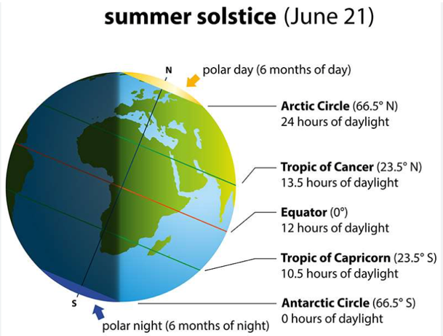
Today is the longest day and it’s also hot and sunny. Thank you, Lord for our summer weather, the flowers and the birds.
For all who did not listen to your Geography teacher or who have forgotten here is a diagram to explain what the Summer Solstice is.
(London is 51°N)

