NOTICES

ST. STEPHEN’S CHAPEL The Family Flower for May is given by Shirley Brown in Remembrance of The Brown Family.

NEW: DEEPER IN FAITH WOMEN’S GROUP A space to slow down, reflect, and grow deeper in faith together through Bible study and friendship on Thursday evenings 7.30-9.30pm every month in the Vicarage. Our next meeting will be on Thursday 4th June. Please speak to Irene Teo or Barbara North.

KITCHEN APPEAL You will see posters and a flyer you have been given about our Kitchen Appeal. Anyone who has been in our kitchen can see how much it needs improvement. We want to future proof our new kitchen so it is ready for whatever St Andrew’s provides in the future from café style tea and coffee to full meals on a regular or occasional basis. We aim to replace the kitchen in August.

HARROW FOOD BANK There is a box at the back of the church for donations. It is taken every month to Harrow Food Bank; let’s see if we can beat last month’s total.


SUMMER PICNIC Join us on the field any time after the 10am service on Sunday 28th June on the field. Bring your own food and drink but there will also be burgers you can buy and ice creams if the weather is hot. There will be live music, a bouncy castle and a play area for little ones. Just sign up to give us an idea of numbers; the cost will be £2 each.

MESSY CHURCH The next Messy Church is on Saturday 13th June and the theme will be David and Goliath. Any offers of help will be greatly appreciated.

SOCIAL EVENTS We are planning more Social Events after the School Holidays so watch this space!

DID YOU KNOW it takes time and effort to count the cash you give us and it costs time, effort and money to pay it into a bank. And banks are becoming fewer and farther away. Have you considered a bank transfer? They’re free to use.

bank details for one-off payments and gifts -
PCC of St Andrew's Roxbourne Parish
Sort code: 40-11-58 Acc No: 20404810
Please note this is not the account for regular Stewardship Giving - please see Wendy Godwin or Peter Sage for those details (Tel: 07889 249500)
S^{T} ANDREW'S CHURCH, ROXBOURNE
 | 89 Malvern Avenue Harrow HA2 9ER.  020 8422 3633 www.standrewsroxbourne.org.uk  Registered Charity No. 1131727 | 

Star Link

SUNDAY, 31st MAY TRINITY SUNDAY
Roxbournestandrews



8.00 am: Holy Communion
10.00 am: Parish Communion
and Children’s Church
Please come to the Hall after the Service for Coffee, Tea & Fellowship

This Week’s Services |  | Next Sunday 7th June
Monday – Friday 9am Morning Prayer  Wednesday 9.30 Communion |  | 8.00 am: Holy Communion  10.00 am: Parish Communion  Hosea 5:15 – ch.6:6; Romans 4: 13-25;  Matthew 9: 9-13 & 18-26
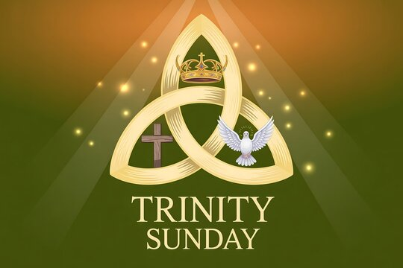

TODAY’S COLLECT

Holy God, faithful and unchanging: enlarge our minds with the knowledge of your truth, and draw us more deeply into the mystery of your love, that we may truly worship you, Father, Son and Holy Spirit, one God, now and for ever. Amen

TODAY’S READINGS
Isaiah 40: 12-17 & 27-31
Who has measured the waters in the hollow of his hand, or with the breadth of his hand marked off the heavens? Who has held the dust of the earth in a basket, or weighed the mountains on the scales and the hills in a balance? Who can fathom the Spirit of the Lord, or instruct the Lord as his counsellor? Whom did the Lord consult to enlighten him, and who taught him the right way? Who was it that taught him knowledge, or showed him the path of understanding? Surely the nations are like a drop in a bucket; they are regarded as dust on the scales; he weighs the islands as though they were fine dust. Lebanon is not sufficient for altar fires, nor its animals enough for burnt offerings. Before him all the nations are as nothing; they are regarded by him as worthless and less than nothing. Why do you complain, Jacob? Why do you say, Israel, “My way is hidden from the Lord; my cause is disregarded by my God”? Do you not know? Have you not heard? The Lord is the everlasting God, the Creator of the ends of the earth. He will not grow tired or weary, and his understanding no one can fathom. He gives strength to the weary and increases the power of the weak. Even youths grow tired and weary, and young men stumble and fall; but those who hope in the Lord will renew their strength. They will soar on wings like eagles; they will run and not grow weary, they will walk and not be faint.

2 Corinthians 13: 11-13
Finally, brothers and sisters, rejoice! Strive for full restoration, encourage one another, be of one mind, live in peace. And the God of love and peace will be with you. Greet one another with a holy kiss. All God’s people here send their greetings.

Matthew 28: 16-20
Now the eleven disciples went to Galilee, to the mountain to which Jesus had directed them. When they saw him, they worshipped him; but some doubted. And Jesus came and said to them, ‘All authority in heaven and on earth has been given to me. Go therefore and make disciples of all nations, baptizing them in the name of the Father and of the Son and of the Holy Spirit, and teaching them to obey everything that I have commanded you. And remember, I am with you always, to the end of the age.’

POST COMMUNION PRAYER

Almighty and eternal God, you have revealed yourself as Father, Son and Holy Spirit, and live and reign in the perfect unity of love: hold us firm in this faith, that we may know you in all your ways and evermore rejoice in your eternal glory, who are three Persons yet one God, now and for ever. Amen
PRAYER DIARY

R I. P.: Ralph Bedford who died on Monday.

This week we remember with thanksgiving the anniversaries of Maurice Varley; Leonard Gray (31st); Brenda Jones (3rd); George Dyer (4th).

Prayer request for healing and other needs: Sue Broatch; Elizabeth Bello; Darrell Campbell; Malcolm George; Sheelagh Gillard; Joyce Nickolay; Pam Storey; Martin Voles; Gary Williams; Angela Zadurian.

Happy Birthday to: Edward Tinsey (31st); Michelle Beasley (1st); Candice Falconer (2nd); Dinesh Jerusalam (4th).

Congratulations to: Mark and Shelley Ellerbeck who were married on 1st June 1994. May they have a happy day together and many more to follow.

Church families: Jenny Kerr; Blessed, Keith and Naveen Kirubakaran; Rev. Sun Ho, Dian, Kang Hak Leer; Kil Boon; Sung Hee Yoon; Simon Lee; Eunsoo Jeon, Da Hee Jeon.

The Parish: Tresco Gardens; Veldene Way; Walton Avenue; Walton Crescent; Warden Avenue; Warden Court; Worple Close; Worple Way; Warwick Avenue; Waverley Road; Yeading Avenue.

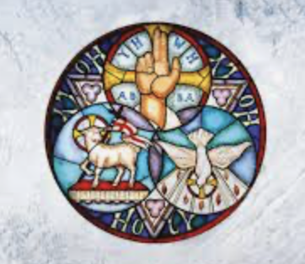
Trinity Sunday is a major Christian feast day that celebrates the doctrine of the Holy Trinity: the belief in one God experienced as three distinct persons—the Father, the Son, and the Holy Spirit. It is observed on the first Sunday after Pentecost. Trinity Sunday is unique because it honours a theological concept and foundational belief. It was defined at The Council of Nicaea in 325AD and established as a feast day in 1334AD.

