NOTICES


CHRISTMAS CHARITY This year the chosen charity we are supporting is St Mungo’s, a charity helping homeless people. Envelopes for donations are in the pews. All donations warmly accepted.


ANGEL TREE Prison Fellowship is a charity which aims to share the Gospel with prisoners in the UK. ANGEL TREE arranges for Christmas presents to be sent to the children of prisoners on behalf of the prisoner. For a number of years now, members of our Congregation have contributed to this charity by buying a present (suggested by the prisoner), or making a donation to help with the cost of postage. Envelopes are available on the Sidespersons table. If you want to know more about this charity do speak to me. Keith Nicholls

CHRISTMAS SERVICES Do join us over Christmas at our special services.
Saturday 20th Dec 7pm Carol Service
Christmas Eve 10.00 am Parish Communion
5.00 pm Crib Service and Christingle
11.30 pm Midnight Mass
Christmas Day 10.00 am Family Christmas Service

MESSY CHURCH The next Messy Church is on Saturday 13th December. The theme will be Christmas. Any offers of help for preparing sandwiches, baking cakes and running activities would be gratefully received. Gill Moore
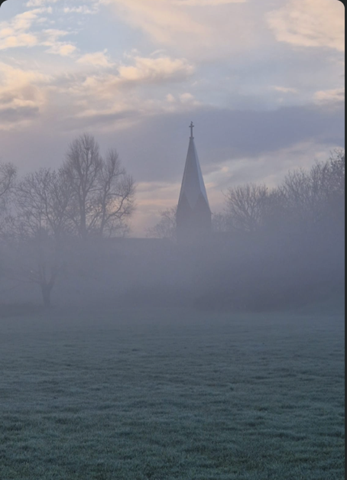

OPEN HOUSE CHRISTMAS AT THE VICARAGE. 7.30pm 17th December.
Drinks, Carols and Nibbles. Please join us.

S^{T} ANDREW'S CHURCH, ROXBOURNE
 | 89 Malvern Avenue Harrow HA2 9ER.  020 8422 3633 www.standrewsroxbourne.org.uk  Registered Charity No. 1131727 | 

Star Link

SUNDAY, 7th DECEMBER 2025 ADVENT 2

Roxbournestandrews



8.00 am: Holy Communion
10.00 am: Parish Communion
with Prayers for Healing
and Children’s Church
Please come to the Hall after the Service for Coffee, Tea & Fellowship

This Week’s Services |  | Next Sunday 14th December
Monday – Friday  9.00 am Morning Prayer [cw]  Wednesday: 9.30am Holy Communion |  | 8.00 am: Holy Communion  10.00 am: Parish Communion  Isaiah 35: 1-10; James 5: 7-10; Matthew 11: 2-11
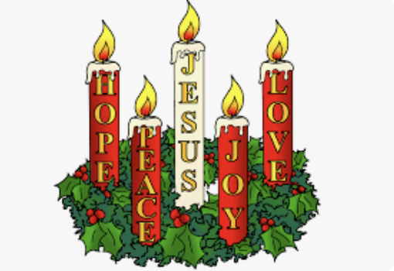
TODAY’S COLLECT

Almighty God, purify our hearts and minds, that when your Son Jesus Christ comes again as judge and saviour we may be ready to receive him, who is our Lord and our God. Amen

TODAY’S READINGS

Isaiah 11: 1-10
A shoot will come up from the stump of Jesse; from his roots a Branch will bear fruit. The Spirit of the Lord will rest on him – the Spirit of wisdom and of understanding, the Spirit of counsel and of might, the Spirit of the knowledge and fear of the Lord – and he will delight in the fear of the Lord. He will not judge by what he sees with his eyes, or decide by what he hears with his ears; but with righteousness he will judge the needy, with justice he will give decisions for the poor of the earth. He will strike the earth with the rod of his mouth; with the breath of his lips he will slay the wicked. Righteousness will be his belt and faithfulness the sash round his waist. The wolf will live with the lamb, the leopard will lie down with the goat, the calf and the lion and the yearling together; and a little child will lead them. The cow will feed with the bear, their young will lie down together, and the lion will eat straw like the ox. The infant will play near the cobra’s den, and the young child will put its hand into the viper’s nest. They will neither harm nor destroy on all my holy mountain, for the earth will be filled with the knowledge of the Lord as the waters cover the sea. In that day the Root of Jesse will stand as a banner for the peoples; the nations will rally to him, and his resting-place will be glorious.

Romans 15.4-13
For everything that was written in the past was written to teach us, so that through the endurance taught in the Scriptures and the encouragement they provide we might have hope. May the God who gives endurance and encouragement give you the same attitude of mind toward each other that Christ Jesus had, so that with one mind and one voice you may glorify the God and Father of our Lord Jesus Christ. Accept one another, then, just as Christ accepted you, in order to bring praise to God. For I tell you that Christ has become a servant of the Jews on behalf of God’s truth, so that the promises made to the patriarchs might be confirmed and, moreover, that the Gentiles might glorify God for his mercy. As it is written: ‘Therefore I will praise you among the Gentiles; I will sing the praises of your name.’ Again, it says, ‘Rejoice, you Gentiles, with his people.’ And again, ‘Praise the Lord, all you Gentiles; let all the peoples extol him.’ And again, Isaiah says, ‘The Root of Jesse will spring up, one who will arise to rule over the nations; in him the Gentiles will hope.’ May the God of hope fill you with all joy and peace as you trust in him, so that you may overflow with hope by the power of the Holy Spirit.

Matthew 3.1-12
Then he looked up at his disciples and said: ‘Blessed are you who are poor, for yours is the kingdom of God. ‘Blessed are you who are hungry now, for you will be In those days John the Baptist appeared in the wilderness of Judea, proclaiming, ‘Repent, for the kingdom of heaven has come near.’ This is the one of whom the prophet Isaiah spoke when he said, ‘The voice of one crying out in the wilderness: “Prepare the way of the Lord, make his paths straight.”’ Now John wore clothing of camel’s hair with a leather belt around his waist, and his food was locusts and wild honey. Then the people of Jerusalem and all Judea were going out to him, and all the region along the Jordan, and they were baptized by him in the river Jordan, confessing their sins. But when he saw many Pharisees and Sadducees coming for baptism, he said to them, ‘You brood of vipers! Who warned you to flee from the wrath to come? Bear fruit worthy of repentance. Do not presume to say to yourselves, “We have Abraham as our ancestor”; for I tell you, God is able from these stones to raise up children to Abraham. Even now the axe is lying at the root of the trees; every tree therefore that does not bear good fruit is cut down and thrown into the fire. ‘I baptize you with water for repentance, but one who is more powerful than I is coming after me; I am not worthy to carry his sandals. He will baptize you with the Holy Spirit and fire. His winnowing-fork is in his hand, and he will clear his threshing-floor and will gather his wheat into the granary; but the chaff he will burn with unquenchable fire.’

POST-COMMUNION PRAYER

Father in heaven, who sent your Son to redeem the world and will send him again to be our judge: give us grace so to imitate him in the humility and purity of his first coming that, when he comes again, we may be ready to greet him with joyful love and firm faith; through Jesus Christ our Lord.
Amen

PRAYER DIARY

The Parish: Dunster Way; Eastcote Lane; Edinburgh Close; Exeter Road; Field End Road; Hamilton Crescent; Harlech Gardens; High Worple; Hodson Close.

Congratulations to: Daniel and Catherine Lyle who were married on 30th November 2024; may they have a happy day together and many more to come.

This week we remember with thanksgiving the anniversaries of: Edward Perry (11th); Alan Wren; Linda Hart (12th).

Prayer request for healing and other needs: Earl Adams; Michael Donnellan; Lenore Marcano – Green; Malcolm George; Emily Rockingham; Pam Storey; Martin Vowles; David Udall; Angela Zadurian.

Church Families: Patricia Ekanem; Mark and Shelley Ellerbeck; Carole Evans; Richard; Candice and Cleo Falconer;

PRAYER FOR THE WEEK

God of power and mercy open our hearts in welcome. Remove the things that hinder us from receiving Christ with joy so that we may share his wisdom and become one with him when he comes in glory, for he lives and reigns with you and the Holy Spirit, one God, forever and ever. Amen.

