NOTICES

FLOWERS The Family flower for November in St. Stephen’s Chapel is in memory of Barbara Wood

BAPTISM Our next Baptism will be on the 30th November, when we will also be welcoming some children for their First Communion. If you would like to be baptised, please see Lyndon

BONFIRE NIGHT, NOVEMBER 5TH was a great success. Thanks to the Scouts for organising the event.

CHRISTMAS SERVICES
Saturday 20th Dec Carol Service 7pm
Christmas Eve Crib Service and Christingle 5pm
Midnight Mass 11.30pm
Christmas Day Family Service 10am

HARROW FOOD BANK Please be generous. There is a box for donations to the Harrow Food Bank at the back of the church. Items needed at the moment are listed on the box. The box will be delivered to the foodbank at the end of the month. David Alleyn
CHRISTMAS MARKET is on Saturday 22nd November, 11am to 3pm. ONLY 2 WEEKS TO GO ST ANDREW’S NEEDS YOU!
This is our main fundraising event of the year.
We really need:
- Christmas decorations and someone to run the stall
- In date bottles for the bottle Tombola
- Unwanted presents for the general Tombola
- Christmas food or financial contributions for the Hamper
- Wrapped sweets, scarves and handbags, any toiletries,
- Children's toys and books.
- Cakes, please bring on Friday 21st, or Saturday morning. Please write the ingredients down.
We will be putting up bunting at 12 noon on the Friday and the tables out and covering them from 12 30 onwards. So please come along and help.
Thank you Social Committee

S^{t} Andrew's Church bank details for one-off payments and gifts -
PCC of St Andrew's Roxbourne Parish
Sort code: 40-11-58 Acc No: 20404810
Please note this is not the account for regular Stewardship Giving - please see Wendy Godwin or Peter Sage for those details (Tel: 07889 249500
S^{T} ANDREW'S CHURCH, ROXBOURNE

 | 89 Malvern Avenue Harrow HA2 9ER.  020 8422 3633 www.standrewsroxbourne.org.uk  Registered Charity No. 1131727 | 

Star Link

SUNDAY, 9th NOVEMBER REMEMBRANCE SUNDAY
Roxbournestandrews



8.00 am: Holy Communion
10.00 am: Parish Communion
with Prayers for Healing
and Children’s Church
Please come to the Hall after the Service for Coffee, Tea & Fellowship

This Week’s Services |  | Next Sunday 16th November
Monday – Friday 9am Morning Prayer  Wednesday 9.30 Communion |  | 8.00 am: Holy Communion  10.00 am: Parish Communion  Malachi 4: 1-2a; 2 Thessalonians 3: 6-13;  Luke 21: 5-19
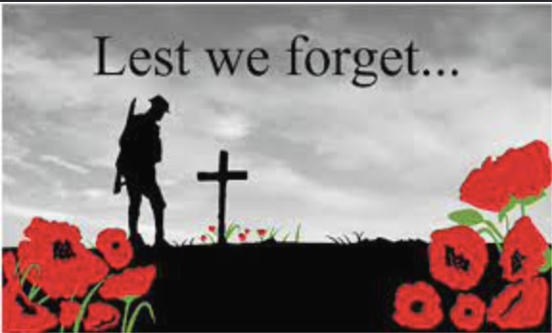

TODAY’S COLLECT
God, our refuge and strength, bring near the day when wars shall cease and poverty and pain shall end, that earth may know the peace of heaven through Jesus Christ our Lord. Amen

TODAY’S READINGS

See Service Sheet

POST-COMMUNION PRAYER

God of peace, whose Son Jesus Christ proclaimed the kingdom and restored the broken to wholeness of life: look with compassion on the anguish of the world, and by your healing power make whole both people and nations; through our Lord and Saviour Jesus Christ. Amen

PRAYER DIARY

The Parish: Worple Close; Worple Way; Warwick Avenue; Waverley Road; Yeading Avenue.

Happy Birthday to: Paul Hart (13th); Tobiloba Adereti (14th); Malcolm George (15th).

This week we remember with thanksgiving the anniversaries of: Iris Bateman (9th); Reginald G Taylor (10th); Rev. Elaine J Garrish (13th); Brian Kendrick (14th).

Prayer request for healing and other needs Earl Adams; Malcolm George; Melaine Louise; Emily Rockingham; Pam Storey; Martin Vowles; Angela Zadurian.

Church Families: Randy Berkley; Robert Bendall; Kiru Baharan; Vanisha Bekal; Ralph Bedford; Elizabeth Bello; Sue Banard; John, Diane, Katie & Emily Bidder; John and Daniel Blanchard; Bernard, Bailey, Riley and Shannell Borley.

PRAYER FOR TODAY

Grant, O Lord, for the sake of those whose lives were lost in war, and for the sake of the generations to come, that the nations of the world may learn your way of peace; and that all may have a chance to enjoy the life you have given them, free from war, tyranny and oppression.

World War 1 – The Great War

WW1 lasted from 1914 to 1918, so great were the deaths and the damage that it was called ‘the war to end all wars’, but peace did not last long. WW2 began in 1939 and lasted until 1945.

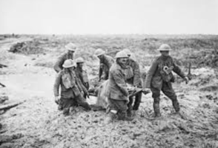
The Western Front
During WW1 much of the fighting took place in Western Europe. The countryside was blasted, bombed and fought over repeatedly. Previously beautiful landscapes turned to mud; bleak and barren scenes where nothing could grow.

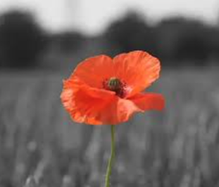
Fields of Poppies
There was a notable and striking exception to the bleakness – the bright red Flanders poppies. These resilient flowers flourished in the middle of so much chaos and destruction, growing in the thousands upon thousands.

Armistice means an agreement to end the fighting of the First World War as a prelude to peace negotiations. It began at 11am on 11 November 1918. (Armistice is Latin for to stop.) To this day we mark Armistice Day around the United Kingdom with a Two Minute Silence at 11am on the 11th day of the 11th month.

At the eleventh hour on the eleventh day of the eleventh month – we will remember them.

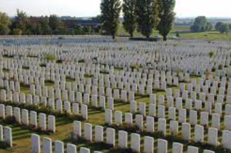
We will remember not only those who died in World War 1 but also World War 2. Since the end of World War Two in 1945, British military forces have been almost constantly engaged in combat operations around the world. From post war occupations, to colonial conflicts, the Cold War against the communists, to today’s wars against Islamic Jihadists, the British military has engaged Britain’s foes.

Today’s conflicts

At any time there is a conflict taking place somewhere in the world. Weapons are far more destructive now and great numbers of civilians are killed along with the military.

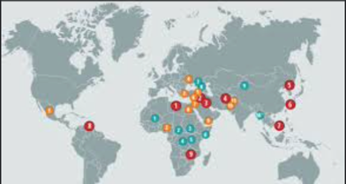
This map shows some of the places where conflicts are taking place now.
We pray for peace throughout the world, particularly in Ukraine, Sudan, Israel and Gaza.

