**NOTICES**

**FLOWERS** The Family flower in St. Stephen’s Chapel for **August** has been given by Sue Brown in loving memory of her mum, Kathleen Taylor

**AUGUST** There will be no **8am services** throughout the month of **August.**

There will be no **Wednesday services** in **August.**

There will be no **Children’s Church** in **August.**

We all deserve a break and will return in September with renewed energy.

**HOLIDAY CLUB** Our **Marvellous Mysteries Holiday Club** was a huge success with 80 children attending each day with approximately 100 over the three days. Thank you to everyone especially Barbara for organising and leading it.

**WELCOME** to Kyrie Malcolm Ron Abbott Tregear, baptised this week.

**QUIZ EVENING** Come to our next social event, the Quiz Evening on **Saturday 4th October**. Bring a team or just turn up and join one. They are always good fun.

**HARROW FOOD BANK CONTAINER:** Is still in operation. Please give your contributions to Lyndon, Enid or David. You may also leave it in a bag at the back of the church. We will store it away daily until collection day. We have a small problem which we are trying to address.  *David Alleyne*

**ST. PAUL’S CATHEDRAL** Why not go up to town and pay a visit to St. Paul’s Cathedral? We have 4 free entry cards which can be used at any time. See me and I will pass them to you, but do remember to return them for the next person to use

*Susan McLeod*

1. St Andrew's Church bank details for one-off payments and gifts -
2. **PCC of St Andrew's Roxbourne Parish**
3. **Sort code: 40-11-58  Acc No: 20404810**
4. *Please note this is not the account for regular Stewardship Giving - please see Wendy Godwin or Peter Sage for those details (Tel: 07889 249500*



**ST ANDREW'S CHURCH, ROXBOURNE**

|  |  |  |
| --- | --- | --- |
| *STAR LOGO 4* | **89 Malvern Avenue Harrow HA2 9ER.**  **020 8422 3633 www.standrewsroxbourne.org.uk**  **Registered Charity No. 1131727** |  |

***Star Link***

|  |  |  |  |
| --- | --- | --- | --- |
|  | | | |
| **SUNDAY, 3rd AUGUST TRINITY 7**  **Welcome to Rev Barry Hingston, today’s celebrant** | | | |
|  | | | Roxbournestandrews |
|  | | |
|  | | |
| **10.00 am: Parish Communion**  **with Prayers for Healing**  *Please come to the Hall after the Service for Coffee, Tea & Fellowship* | | |
| **This Week’s Services** |  | **Next Sunday 10th August** | |
| **Monday – Friday 9am Morning Prayer** |  | **10.00 am: Parish Communion**  *Isaiah 1: 1 & 10-20; Hebrews 11: 1-3 & 8-16;*  *Luke 12: 32-40* | |
|  |

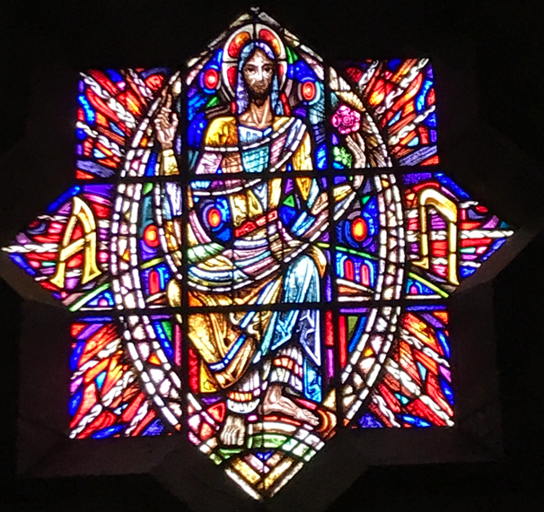

TODAY’S COLLECT

**Generous God you give us gifts and make them grow: though our faith is small as mustard seed, make it grow to your glory and the flourishing of your kingdom; through Jesus Christ our Lord. Amen**

TODAY’S READINGS

***Hosea 11: 1-11***

“When Israel was a child, I loved him, and out of Egypt I called my son.But the more they were called, the more they went away from me. They sacrificed to the Baals and they burned incense to images.It was I who taught Ephraim to walk taking them by the arms; but they did not realise it was I who healed them.I led them with cords of human kindness, with ties of love. To them I was like one who lifts a little child to the cheek, and I bent down to feed them.“Will they not return to Egypt and will not Assyria rule over them because they refuse to repent?A sword will flash in their cities; it will devour their false prophets and put an end to their plans.My people are determined to turn from me. Even though they call me God Most High, I will by no means exalt them.“How can I give you up, Ephraim? How can I hand you over, Israel? How can I treat you like Admah? How can I make you like Zeboyim? My heart is changed within me; all my compassion is aroused.I will not carry out my fierce anger, nor will I devastate Ephraim again. For I am God, and not a man— the Holy One among you. I will not come against their cities.They will follow the Lord; he will roar like a lion. When he roars, his children will come trembling from the west.They will come from Egypt, trembling like sparrows, from Assyria, fluttering like doves. Iwill settle them in their homes,” declares the Lord.

***Colossians 3: 1-11***

Since, then, you have been raised with Christ, set your hearts on things above, where Christ is, seated at the right hand of God. Set your minds on things above, not on earthly things. For you died, and your life is now hidden with Christ in God. When Christ, who is your life, appears, then you also will appear with him in glory.Put to death, therefore, whatever belongs to your earthly nature: sexual immorality, impurity, lust, evil desires and greed, which is idolatry. Because of these, the wrath of God is coming. You used to walk in these ways, in the life you once lived. But now you must also rid yourselves of all such things as these: anger, rage, malice, slander, and filthy language from your lips. Do not lie to each other, since you have taken off your old self with its practicesand have put on the new self, which is being renewed in knowledge in the image of its Creator. Here there is no Gentile or Jew, circumcised or uncircumcised, barbarian, Scythian, slave or free, but Christ is all, and is in all.

***Luke 12: 13-21***

Someone in the crowd said to him, ‘Teacher, tell my brother to divide the family inheritance with me.’ But he said to him, ‘Friend, who set me to be a judge or arbitrator over you?’ And he said to them, ‘Take care! Be on your guard against all kinds of greed; for one’s life does not consist in the abundance of possessions.’ Then he told them a parable: ‘The land of a rich man produced abundantly. And he thought to himself, “What should I do, for I have no place to store my crops?” Then he said, “I will do this: I will pull down my barns and build larger ones, and there I will store all my grain and my goods. And I will say to my soul, Soul, you have ample goods laid up for many years; relax, eat, drink, be merry.” But God said to him, “You fool! This very night your life is being demanded of you. And the things you have prepared, whose will they be?” So it is with those who store up treasures for themselves but are not rich towards God.’

**POST COMMUNION PRAYER**

**Lord God, whose Son is the true vine and the source of life; ever giving himself that the world may live: may we so receive within ourselves the power of his death and passion that, in his saving cup, we may share his glory and be made perfect in his love; for he is alive and reigns, now and for ever. Amen**

**PRAYER DIARY**

**The Parish** Lynwood Close; Malvern Avenue; Meadfield; Merlins Avenue; Minehead Court; Minehead Road Mirren Close; Newlyn Gardens; Newquay Crescent.

**Happy Birthday to** Alestir Smith (5th); Ros Williams (6th); Sheila Tucker (7th); Virgin Flower Leon (8th); Audar Leon (9th).

**This week we remember with thanksgiving the anniversary of:** John Yates (4th).

**Prayer request for healing and other needs** Earl Adams; David Alleyne;Elizabeth Bello; Shannell Bortey; Mark Gardiner; Malcolm George; Broden Kiely; Emily Rockingham; Pam Storey; Martin Vowles; Angela Zadurian.

**Church Families:** Harry Maddison; Pearl Marcano; Leonore Marcano – Green; Orley, Simone, Althea McIntyre; Susan McLeod; Letitia and Emma Mihali; Kulan and Chris Mills; Roger and Gill Moore; John and Christina Murch; Georgina Muxlow.

**Congratulations to:** Allan and Elizabeth Tinseywho were married on 6th August 1966 may they have a happy day together and many more to come.

.

**PRAYER FOR THIS WEEK**

**Heavenly Father, Thank You for the gift of a new month. As I step into August, I place my life, my plans, and my loved ones into Your hands. Let this month be filled with Your presence, peace, and purpose. Lord, go before me and make every crooked path straight.**

