**NOTICES**

**MESSY CHURCH** The next Messy Church is on **Saturday 14th June** and the theme will be Pentecost. *Gill Moore*

**HOLIDAY CLUB** We are hoping to run a Holiday Club again this year.The prospective dates are **Wednesday 23rd to Friday 25th July**.Please let me know if you can help. Thank you. *Barbara*

**HARROW FOOD BANK** There is a box for donations to the Harrow Food Bank at the back of the church.In April we collected **13.45 kg** of food and other items. Let’s hope May’s total is even more. *David*

**PARISH DIRECTORY** If you would like to be included in our Parish Directory please let Joyce Nickolay know. Being in the Directory makes it easier for you to get in touch with anyone from St. Andrew’s and for any of us to get in touch with you.

**LITTLE STEPS**  St Andrew's Parent and Toddler Group meets every Friday 10 to 11.3am during term time in the Large Hall. Stay and play sessions for under 5s and parents, grandparents and carers. *Annie and team*

**YOUTH CLUB** Our Friday night Youth Club for teenagers goes from strength to strength. Many thanks to our dedicated team of leaders and especially the new young people who have recently joined our team. It will resume this Friday after the half term break.

**ST. PAUL’S CATHEDRAL** Why not go up to town and pay a visit to St. Paul’s Cathedral? We have 2 free entry cards which can be used at any time. See me and I will pass them to you, but do remember to return them for the next person to use. *Susan*

**ST. ANDREW’S CHURCH** We all know how beautiful our church is. Now it is officially listed as a **Building of Special Architectural /Historic Interest, Grade II**

1. St Andrew's Church bank details for one-off payments and gifts -
2. **PCC of St Andrew's Roxbourne Parish**
3. **Sort code: 40-11-58  Acc No: 20404810**
4. *Please note this is not the account for regular Stewardship Giving - please see Wendy Godwin or Peter Sage for those details (Tel: 07889 249500*

***Please send any items for next week’s STARLINK to Susan McLeod by midday this Friday, preferably by email (***[***mcleod383@btinternet.com***](mailto:mcleod383@btinternet.com)***), or otherwise by hard copy to 8 Drake Road.***

**ST ANDREW'S CHURCH, ROXBOURNE**

|  |  |  |
| --- | --- | --- |
| *STAR LOGO 4* | **89 Malvern Avenue Harrow HA2 9ER.**  **020 8422 3633 www.standrewsroxbourne.org.uk**  **Registered Charity No. 1131727** |  |

***Star Link***

|  |  |  |  |
| --- | --- | --- | --- |
|  | | | |
| **SUNDAY, 1st JUNE EASTER 7** | | | |
|  | | | Roxbournestandrews |
|  | | |
|  | | |
| **8.00 am: Holy Communion**  **10.00 am: Parish Communion**  **with Prayers for Healing**  *and* **Children’s Church**  *Please come to the Hall after the Service for Coffee, Tea & Fellowship* | | |
| **This Week’s Services** |  | **Next Sunday 8sh June** | |
| **Monday – Friday 9am Morning Prayer**  **Wednesday 9.30 Communion** |  | **8.00 am:** Holy Communion  **10.00 am: Parish Communion**  *Genesis 11: 1-9; Acts 2: 1-21;*  *John 14: 8-17 & 25-27* | |
|  |
|  |

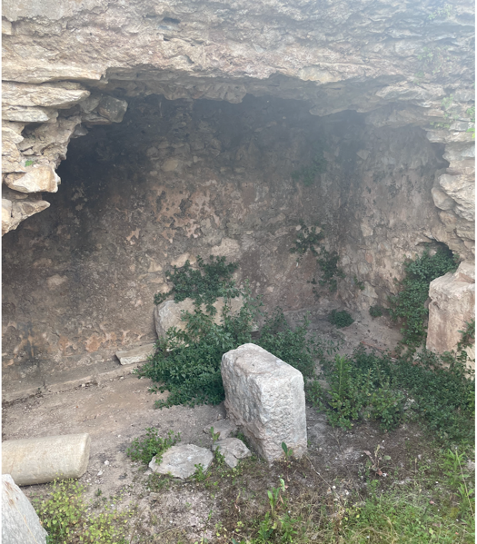

This is believed to be the remains of the cell where Paul and Silas were held in Philippi.

TODAY’S COLLECT

**Risen, ascended Lord, as we rejoice at your triumph, fill your Church on earth with power and compassion, that all who are estranged by sin may find forgiveness and know your peace, to the glory of God the Father. Amen**

TODAY’S READINGS

***Ezekiel 36: 24-28***

“‘For I will take you out of the nations; I will gather you from all the countries and bring you back into your own land. I will sprinkle clean water on you, and you will be clean; I will cleanse you from all your impurities and from all your idols. I will give you a new heart and put a new spirit in you; I will remove from you your heart of stone and give you a heart of flesh. And I will put my Spirit in you and move you to follow my decrees and be careful to keep my laws. Then you will live in the land I gave your ancestors; you will be my people, and I will be your God.

***Acts 16: 16-34***

Once when we were going to the place of prayer, we were met by a female slave who had a spirit by which she predicted the future. She earned a great deal of money for her owners by fortune-telling. She followed Paul and the rest of us, shouting, “These men are servants of the Most High God, who are telling you the way to be saved.” She kept this up for many days. Finally Paul became so annoyed that he turned around and said to the spirit, “In the name of Jesus Christ I command you to come out of her!” At that moment the spirit left her.When her owners realized that their hope of making money was gone, they seized Paul and Silas and dragged them into the marketplace to face the authorities. They brought them before the magistrates and said, “These men are Jews, and are throwing our city into an uproar by advocating customs unlawful for us Romans to accept or practice.”The crowd joined in the attack against Paul and Silas, and the magistrates ordered them to be stripped and beaten with rods. After they had been severely flogged, they were thrown into prison, and the jailer was commanded to guard them carefully. When he received these orders, he put them in the inner cell and fastened their feet in the stocks.About midnight Paul and Silas were praying and singing hymns to God, and the other prisoners were listening to them. Suddenly there was such a violent earthquake that the foundations of the prison were shaken. At once all the prison doors flew open, and everyone’s chains came loose. The jailer woke up, and when he saw the prison doors open, he drew his sword and was about to kill himself because he thought the prisoners had escaped. But Paul shouted, “Don’t harm yourself! We are all here!”The jailer called for lights, rushed in and fell trembling before Paul and Silas. He then brought them out and asked, “Sirs, what must I do to be saved?”They replied, “Believe in the Lord Jesus, and you will be saved—you and your household.” Then they spoke the word of the Lord to him and to all the others in his house.At that hour of the night the jailer took them and washed their wounds; then immediately he and all his household were baptized. The jailer brought them into his house and set a meal before them; he was filled with joy because he had come to believe in God—he and his whole household.

***John 17: 20-26***

I ask not only on behalf of these, but also on behalf of those who will believe in me through their word, that they may all be one. As you, Father, are in me and I am in you, may they also be in us, so that the world may believe that you have sent me. The glory that you have given me I have given them, so that they may be one, as we are one, I in them and you in me, that they may become completely one, so that the world may know that you have sent me and have loved them even as you have loved me.Father, I desire that those also, whom you have given me, may be with me where I am, to see my glory, which you have given me because you loved me before the foundation of the world.‘Righteous Father, the world does not know you, but I know you; and these know that you have sent me. I made your name known to them, and I will make it known, so that the love with which you have loved me may be in them, and I in them.’

**POST COMMUNION PRAYER**

**Eternal God, giver of love and power, your Son Jesus Christ has sent us into all the world to preach the gospel of his kingdom: confirm us in this mission, and help us to live the good news we proclaim; through Jesus Christ our Lord. Amen**

**PRAYER DIARY**

**The Parish**: Mirren Close; Newlyn Gardens; Newquay Crescent; Ovesdon Avenue; Pembroke Avenue; Perwell Avenue; Perwell Court; Primrose Close; Ravenswood Crescent.

**Happy Birthday to;** Michelle Beasley (1st); Candice Falconer (2nd); Geoff Sweet (3rd); Dinesh Jerrusham (4th); Bukky Adereti (5th).

**Congratulations to:** Carlos A. M. and Mayea A. M. Desantos who were married on 3rd June 2020. May they have a happy day together and many more to follow.

**This week we remember with thanksgiving the anniversaries of:** Brenda Perry; Evelyn Jones (3rd); George Dyer (4th);

**Prayer request for healing and other needs:**  David Alleyne;Ralph Bedford;Elizabeth Bello; Shannell Bortey; Ann – Marie Cunynham; Melaine Louise; Orlanda Greyson; Glen Pyne; Pam Storey; Martin Vowles; Angela Zadurian.

**Church Families:** Paul Hart; Pauline Harrowell; Simon, Callum, Chloe and Eleanor Hill; Alan Heyes; Reiss Hinds; Martin Hollaway; Joyce Hughes.

**PRAYER FOR THIS WEEK**

**Risen and ascended Christ, we proclaim you to be our King. Rule over our lives, that we may display your reign in who we are and in all we do; for you are the King of glory, now and always. Amen.**