##### NOTICES I have Christmas and Advent Books from

##### LYNDON Would you like a visit from Lyndon to your home during Lent? Please sign up at the back on the church notice board and Lyndon will be in touch.

##### LENT APPEAL This year we are supporting SPARKS, a local group for Tamil neurodiverse children, which meets weekly here at St. Andrew’s. See posters for more information.

##### 

##### CHURCH SPRING CLEAN and LENT LUNCH Come and help our Spring Clean on Saturday 5th April from 10.00am. We want St Andrew’s to sparkle inside and outside in time for Easter! To make the day easier and keep up your energy levels there will be a Lent Lunch in the main hall from 12.30. *Church Wardens*

##### STAINER’S CRUCIFIXION is being performed at St Albans Church next Saturday 5th April at 5.30pm by Harrow Choral Society For tickets please contact Keith Nicholls (07769 738 495) or the website harrowchoral.org.uk. Thank you.

**LENT WALK** My dog and I are leading a Lent Walk around the parish boundary on **Wednesday 9th April** beginning at **10.30am,** starting and ending at St Andrews. The distance is approximately 5.5 miles. My family are supporting us to raise money for Sparks. If you want to join us, please be at the church by 10.15am. All children need to be with a responsible adult throughout. Take part just for fun or to raise money for Sparks or your chosen charity.  *Annie Dawson*

**MESSY CHURCH** The next Messy Church is on **Saturday 12th April** and the theme will be **Easter.** *Gill Moore*

**CONFIRMATION SERVICE** at St Andrew's with the Bishop of London on **Sunday 18th May**. If you would like to be confirmed please speak to Lyndon.

**BIBLE STUDY NOTES** It's time to renew the Bible Study notes. The cost for the whole year will be £15.75 per person. If you would like to see examples of the Bible study notes there are some at the back of the church. Please let me know if you would like to order these notes and also if you would like to continue to receive them. Thank you.*Gill Moore*

1. St Andrew's Church bank details for one-off payments and gifts -
2. **PCC of St Andrew's Roxbourne Parish**
3. **Sort code: 40-11-58  Acc No: 20404810**
4. *Please note this is not the account for regular Stewardship Giving - please see Wendy Godwin or Peter Sage for those details (Tel: 07889 249500*

***Please send any items for next week’s STARLINK to Susan McLeod by midday this Friday, preferably by email (***[***mcleod383@btinternet.com***](mailto:mcleod383@btinternet.com)***), or otherwise by hard copy to 8 Drake Road.***

**ST ANDREW'S CHURCH, ROXBOURNE**

|  |  |  |
| --- | --- | --- |
| *STAR LOGO 4* | **89 Malvern Avenue Harrow HA2 9ER.**  **020 8422 3633 www.standrewsroxbourne.org.uk**  **Registered Charity No. 1131727** |  |

***Star Link***

|  |  |  |  |
| --- | --- | --- | --- |
|  | | | |
| **SUNDAY, 30th MARCH MOTHERING SUNDAY** | | | |
|  | | | Roxbournestandrews |
|  | | |
|  | | |
| **8.00 am: Holy Communion**  **10.00 am: Parish Communion**  **with Prayers for Healing**  *and* **Children’s Church**  *Please come to the Hall after the Service for Coffee, Tea & Fellowship* | | |
| **This Week’s Services** |  | **Next Sunday 6th April** | |
| **Monday – Friday**  9.00 am Morning Prayer [cw]  **Wednesday**: 9.30am Holy Communion |  | **8.00 am:** Holy Communion  **10.00 am: Parish Communion**  *Isaiah 43: 16-21; Philippians 3: 4b-14;*  *John 12: 1-8* | |
|  |
|  |

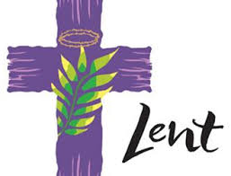

TODAY’S COLLECT

**God of love, passionate and strong, tender and careful: watch over us and hold us all the days of our life; through Jesus Christ our Lord. Amen**

TODAY’S READINGS

***Exodus 2: 1-10***

Now a man of the tribe of Levi married a Levite woman,and she became pregnant and gave birth to a son. When she saw that he was a fine child, she hid him for three months.But when she could hide him no longer, she got a papyrus basket for him and coated it with tar and pitch. Then she placed the child in it and put it among the reeds along the bank of the Nile. His sister stood at a distance to see what would happen to him.Then Pharaoh’s daughter went down to the Nile to bathe, and her attendants were walking along the riverbank. She saw the basket among the reeds and sent her female slave to get it. She opened it and saw the baby. He was crying, and she felt sorry for him. “This is one of the Hebrew babies,” she said.Then his sister asked Pharaoh’s daughter, “Shall I go and get one of the Hebrew women to nurse the baby for you?”“Yes, go,” she answered. So the girl went and got the baby’s mother. Pharaoh’s daughter said to her, “Take this baby and nurse him for me, and I will pay you.” So the woman took the baby and nursed him. When the child grew older, she took him to Pharaoh’s daughter and he became her son. She named him Moses, saying, “I drew him out of the water.”

***2 Corinthians 1: 3-7***

Praise be to the God and Father of our Lord Jesus Christ, the Father of compassion and the God of all comfort, who comforts us in all our troubles, so that we can comfort those in any trouble with the comfort we ourselves receive from God. For just as we share abundantly in the sufferings of Christ, so also our comfort abounds through Christ. If we are distressed, it is for your comfort and salvation; if we are comforted, it is for your comfort, which produces in you patient endurance of the same sufferings we suffer. And our hope for you is firm, because we know that just as you share in our sufferings, so also you share in our comfort.

***John 19: 25-27***

Meanwhile, standing near the cross of Jesus were his mother, and his mother’s sister, Mary the wife of Clopas, and Mary Magdalene. When Jesus saw his mother and the disciple whom he loved standing beside her, he said to his mother, ‘Woman, here is your son.’ Then he said to the disciple, ‘Here is your mother.’ And from that hour the disciple took her into his own home.

**POST COMMUNION PRAYER**

**Loving God, as a mother feeds her children at the breast you feed us in this sacrament with the food and drink of eternal life: help us who have tasted your goodness to grow in grace within the household of faith; through Jesus Christ our Lord. Amen**

**PRAYER DIARY**

**The Parish**: Lynwood Close; Malvern Avenue; Meadfield; Merlins Avenue; Minehead Court; Minehead Road; Mirren Close; Newlyn Gardens; Newquay Crescent.

**Happy Birthday to;** Chris Mills (31st); Brenda Udall (1st); Easmie Williams (2nd).

**Congratulations to:** Geoffrey and Judith Grice who were married on 31st March 1986.; also to Peter and Georgina Sage who were married **sixty** **years** ago on 3rd April 1965. May both couples have a happy together and many more to come.

**This week we remember with thanksgiving the anniversaries of:** George Sandell (31st); Lollie Prower (2nd); Wilfred Smith (3rd); Vera Bendall; Sam Hanson; Terry Abernethy (4th).

**Prayer request for healing and other needs:**  Elizabeth Bello; Shannelle Bortey; Melaine Louise; Orlanda Greyson; Gill Moore; Alan Heyes; Pam Storey; Martin Vowles; Angela Zadurian.

**Church Families:** Russell, Hezekiah, Jesse and Lara Simonot; Belinda Szymanski; Anushka Swan; Alestir,Naomiand Sandra Smith; Omid and Sally Sarafan; Alan, Edward, Marina and Elizabeth Tinsey; Karen Titmuss; Sheila Tucker; Christopher and Marian Twentyman.

**PRAYER FOR MOTHERING SUNDAY**

**Jesus, like a mother you gather your people to you; you are gentle with us as a mother with her children. Despair turns to hope through your sweet goodness; through your gentleness we find comfort in fear.**

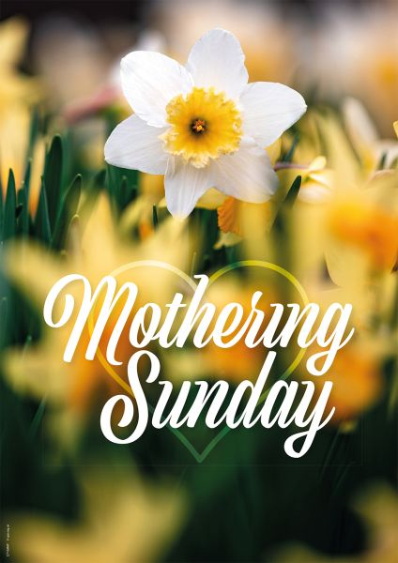

**MOTHERING SUNDAY began as a religious event of the 16th Century, with no connection to mothers at all. The word "mothering" referred to the "mother church", meaning the main church or cathedral of the region. It became a tradition that, on the fourth Sunday of Lent, people would return to their mother church for a special service. This pilgrimage became something of a holiday event, with domestic servants traditionally given the day off to visit their own families as well as their mother church.**