##### NOTICES I have Christmas and Advent Books from S

##### HARROW FOOD BANK There is a box for donations to the Harrow Food Bank at the back of the church. Items needed at the moment are listed on the box. We collected 13 kg in items for the food bank this month. Thank you. *David Alleyn*

##### SUNDAY COLLECTIONS     Have you wondered why so few people put money in our weekly collections?  Most people committed to St. Andrew’s pay by Standing Order and if they pay tax we can claim Gift aid. If you don’t please think about it. Standing Orders help as no-one has to count the cash and pay it in to the bank. If you want to know more, please see Wendy Godwin or contact on 07889 249500 or by email [wendygodwin@aol.com](mailto:wendygodwin@aol.com)

**MESSY CHURCH** We had 40 children and parents and grandparents who attended the last Messy Church and they had great fun trying out a variety of activities. Many thanks to everyone who supported this. The next Messy Church is on **Saturday 8th March**. *Gill. Moore*

**LENT GROUPS MEETINGS Ash Wednesday** is **5th March**, and our Lent Groups will start to meet in the week commencing **Monday 10th March**. We will be using the book **“At Home in Lent”** by Gordon Giles. The book invites us to consider everyday household objects and relate them to spiritual aspects of Lent. Each object is linked to a short Bible reading. The book explains how we can find God in the normal pattern of life – even in the mundane.

We hope you will be able to join one of the groups for five sessions during Lent. You do not have to attend every week. More details about the groups are on the leaflet you have received today, and on the notice at the back of Church.

**CONFIRMATION SERVICE** at St Andrew's with the Bishop of London on **Sunday 18th** **May**. If you would like to be confirmed please speak to Lyndon.

**LOST** Silver, hallmarked table spoon mislaid at International Evening. Please look for it. Sentimental value as it was my mum’s. Thanks. *Susan McLeod*

1. St Andrew's Church bank details for one-off payments and gifts -
2. **PCC of St Andrew's Roxbourne Parish**
3. **Sort code: 40-11-58  Acc No: 20404810**
4. *Please note this is not the account for regular Stewardship Giving - please see Wendy Godwin or Peter Sage for those details (Tel: 07889 249500*

***Please send any items for next week’s STARLINK to Susan McLeod by midday this Friday,***

***preferably by email (***[***mcleod383@btinternet.com***](mailto:mcleod383@btinternet.com)***), or otherwise by hard copy to 8 Drake Road.***

**ST ANDREW'S CHURCH, ROXBOURNE**

|  |  |  |
| --- | --- | --- |
| *STAR LOGO 4* | **89 Malvern Avenue Harrow HA2 9ER.**  **020 8422 3633 www.standrewsroxbourne.org.uk**  **Registered Charity No. 1131727** |  |

***Star Link***

|  |  |  |  |
| --- | --- | --- | --- |
|  | | | |
| **SUNDAY, 16th FEBRUARY 2025**  **3rd SUNDAY BEFORE LENT**  **Welcome to Rev Barry Higson, our celebrant today.** | | | |
|  | | | Roxbournestandrews |
|  | | |
|  | | |
| **8.00 am: Holy Communion**  **10.00 am: Parish Communion**  **with Prayers for Healing**  *and* **Children’s Church**  *Please come to the Hall after the Service for Coffee, Tea & Fellowship* | | |
| **This Week’s Services** |  | **Next Sunday 23rd February** | |
| **Monday – Friday**  9.00 am Morning Prayer [cw]  **Wednesday**: 9.30am Holy Communion |  | **8.00 am:** Holy Communion  **10.00 am: Parish Communion**  *Genesis 2: 4b-9 & 15-25; Revelation 4; Luke 8: 22-25* | |
|  |
|  |

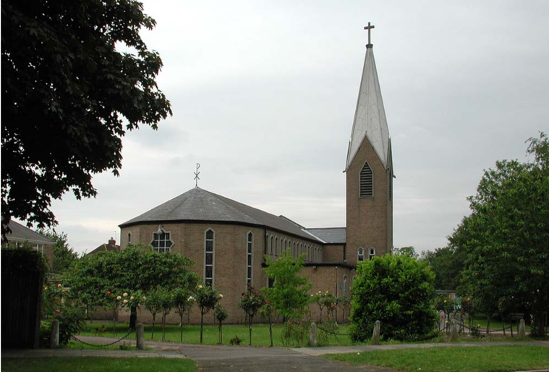

TODAY’S COLLECT

**Eternal God, whose Son went among the crowds and brought healing with his touch: help us to show his love, in your Church as we gather together, and by our lives as they are transformed into the image of Christ our Lord.**

**Amen**

TODAY’S READINGS

***Jeremiah 17: 5-10***

This is what the Lord says: “Cursed is the one who trusts in man, who draws strength from mere flesh and whose heart turns away from the Lord. That person will be like a bush in the wastelands; they will not see prosperity when it comes. They will dwell in the parched places of the desert, in a salt land where no one lives.“But blessed is the one who trusts in the Lord, whose confidence is in him.They will be like a tree planted by the water that sends out its roots by the stream. It does not fear when heat comes; its leaves are always green. It has no worries in a year of drought and never fails to bear fruit.”The heart is deceitful above all things and beyond cure. Who can understand it?“I the Lord search the heart and examine the mind, to reward each person according to their conduct, according to what their deeds deserve.”

***I Corinthians 15: 12-20***

But if it is preached that Christ has been raised from the dead, how can some of you say that there is no resurrection of the dead? If there is no resurrection of the dead, then not even Christ has been raised. And if Christ has not been raised, our preaching is useless and so is your faith.More than that, we are then found to be false witnesses about God, for we have testified about God that he raised Christ from the dead. But he did not raise him if in fact the dead are not raised. For if the dead are not raised, then Christ has not been raised either. And if Christ has not been raised, your faith is futile; you are still in your sins. Then those also who have fallen asleep in Christ are lost. If only for this life we have hope in Christ, we are of all people most to be pitied.But Christ has indeed been raised from the dead, the first fruits of those who have fallen asleep.

***Luke 6: 17-26***

He came down with them and stood on a level place, with a great crowd of his disciples and a great multitude of people from all Judea, Jerusalem, and the coast of Tyre and Sidon. They had come to hear him and to be healed of their diseases; and those who were troubled with unclean spirits were cured. And all in the crowd were trying to touch him, for power came out from him and healed all of them. Then he looked up at his disciples and said: ‘Blessed are you who are poor, for yours is the kingdom of God.‘Blessed are you who are hungry now, for you will be filled. ‘Blessed are you who weep now, for you will laugh.‘Blessed are you when people hate you, and when they exclude you, revile you, and defame you[[a](https://www.biblegateway.com/passage/?search=Luke%206%3A%2017-26&version=NRSVA#fen-NRSVA-25161a)] on account of the Son of Man. Rejoice on that day and leap for joy, for surely your reward is great in heaven; for that is what their ancestors did to the prophets.‘But woe to you who are rich, for you have received your consolation.‘Woe to you who are full now, for you will be hungry. ‘Woe to you who are laughing now, for you will mourn and weep.‘Woe to you when all speak well of you, for that is what their ancestors did to the false prophets.

**POST COMMUNION PRAYER**

**Merciful Father, who gave Jesus Christ to be for us the bread of life, that those who come to him should never hunger: draw us to the Lord in faith and love, that we may eat and drink with him at his table in the kingdom, where he is alive and reigns, now and for ever. Amen**

**PRAYER DIARY**

**The Parish:** Worple Close; Worple Way; Warwick Avenue; Waverley Road; Yeading Avenue.

**Happy Birthday to:** Melaine Dunscombe; Dominique Thompson; Michael Purice (17th); Carole Evans (20th).

**This week we remember with thanksgiving the anniversaries of:** Pax Chinnakone (17th); Pamela Austin (20th); Doreen Moyse (21st); Maude Wellington (22nd).

**Prayer request for healing and other needs:** Ralph Bedford;Elizabeth Bello; Shannell Bortey; Gill Moore; Pam Storey; Martin Vowles; Angela Zadurian.

**Church Families:** Robinson and RobinaIhesiene; Nemo Isaac; Ratnasapathy and Nerhu Janagan; Koungmi Kwon, Jounghoon, Suhyung and Taeyang Kwon.

**PRAYER FOR THIS WEEK**

Almighty God, who alone can bring order to the unruly wills and passions of sinful humanity: give your people grace so to love what you command and to desire what you promise, that, among the many changes of this world, our hearts may surely there be fixed where true joys are to be found; through Jesus Christ your Son our Lord.

