**NOTICES**

**CHURCH HALL BOOKINGS IN 2024 FOR CHURCH EVENTS** Please let me know the dates I should reserve for church events as I have started taking bookings and answering availability enquiries for 2024.  You may send text to 075 7878 9099 or email [starlet3633@gmail.com](mailto:starlet3633@gmail.com)   *Martin (Hall Lettings Secretary)*

**BONFIRE NIGHT, NOVEMBER 5TH** was a great success. Thanks to the Scouts for organising the event.

**CHRISTMAS MARKET** ***ONLY 6 DAYS TO GO!!!***

**Last chance!**

Please bring any cakes Friday afternoon or Saturday morning.  Ideally, they should have a list of ingredients with them, essential if they have any nuts in them.

We need help on Friday 15th. to put up the bunting at 12.30pm and then people to help move the screen and to put out the tables and cover them, from about 1.00pm onwards.

Please take a leaflet from the back of the church and pop it through a neighbour’s door and tell everybody about the market!

If you're running a stall, please wear something festive! *Gill Moore*

**CAROL SERVICE** this year is at **7pm** **on Saturday 21st December**. *Robert Crowhurst*

**HARROW FOOD BANK Please be generous.** There is a box for donations to the Harrow Food Bank at the back of the church.Items needed at the moment are listed on the box. The box will be delivered to the foodbank at the end of the month. *David Alleyne*

**COMING SOON – ANGEL TREE 2024**

**Prison Fellowship** is a charity which aims to share the Gospel with prisoners in the UK and across the world. **ANGEL TREE** (part of Prison Fellowship) arranges for Christmas presents to be sent to the children of prisoners on behalf of a prisoner. It is impossible for prisoners to arrange this themselves. Each prisoner is invited to provide the details of their children and suggestions for a suitable present. A volunteer then buys a present (spending about £20), and **ANGEL TREE** arranges for it to be sent off in time for Christmas. Many members of our Congregation have contributed to this charity in past years.. Please let me know if you will volunteer to buy a present..

Thank you *Keith Nicholls: keithjnicholls@gmail.com*

     

**ST ANDREW'S CHURCH, ROXBOURNE**

|  |  |  |
| --- | --- | --- |
| *STAR LOGO 4* | **89 Malvern Avenue Harrow HA2 9ER.**  **020 8422 3633 www.standrewsroxbourne.org.uk**  **Registered Charity No. 1131727** |  |

***Star Link***

|  |  |  |  |
| --- | --- | --- | --- |
|  | | | |
| **SUNDAY, 10th NOVEMBER 2024**  REMEMBRANCE SUNDAY | | | |
|  | | | Roxbournestandrews |
|  | | |
|  | | |
| **8.00 am: Holy Communion**  **10.00 am: Parish Communion**  **with Prayers for Healing**  *and* **Children’s Church**  *Please come to the Hall after the Service for Coffee, Tea & Fellowship* | | |
| **This Week’s Services** |  | **Next Sunday 17th November** | |
| **Monday – Friday**  9.00 am Morning Prayer [cw]  **Wednesday**: 9.30am Holy Communion |  | **8.00 am:** Holy Communion  **10.00 am: Parish Communion**  *Ecclesiastes 3: 1-8; I Peter 2: 13-25; John 15: 1-13* | |
|  |
|  |

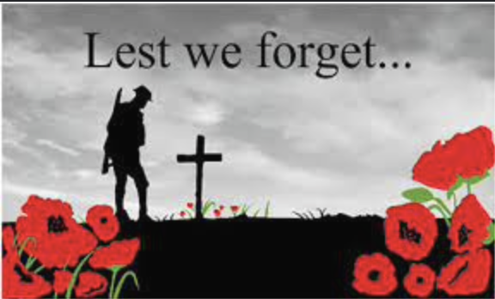

TODAY’S COLLECT

1. **God, our refuge and strength bring near the day when wars shall cease and poverty and pain shall end, that earth may know the peace of heaven through Jesus Christ our Lord. Amen**

TODAY’S READINGS

See Service Sheet

**POST COMMUNION PRAYER**

**God of peace, whose Son Jesus Christ proclaimed the kingdom and restored the broken to wholeness of life: look with compassion on the anguish of the world, and by your healing power make whole both people and nations; through our Lord and Saviour Jesus Christ. Amen**

**PRAYER DIARY**

**This week we remember with thanksgiving the anniversaries of:** Rev Elaine Garrish (13th); Brian Hendrick (14th)

**Prayer request for healing and other needs:** Elizabeth Bello; Shannell Borley; Melanie; Michael Donnellan; Keith and Sue Nicholls; Jean McIntyre; Gill Moore; Reg Paine; Pam Storey.

**Happy Birthday to:** Paul Hart (13th); Alan Tinsey; Tobiloba Adereti (14th); Malcolm George (15th); Shirline Williams, Sandra Smith (16th).

**The Parish: Our Schools:** Alexandra Special; Heathland; Moriah Jewish; Newton farm; Rooks Heath; Roxbourne.

**Church Families:** Eriabu Nakabale; Keith and Sue Nicholls; Joyce Nickolay; Chris Netsel and Pam Quartermain.

**PRAYER FOR THE WEEK**

**Grant, O Lord, for the sake of those whose lives were lost in war, and for the sake of the generations to come, that the nations of the world may learn your way of peace; and that all may have a chance to enjoy the life you have given them, free from war, tyranny and oppression.**

     

**World War 1 – The Great War**

WW1 lasted from 1914 to 1918, so great were the deaths and the damage that it was called ‘the war to end all wars’, but peace did not last long. WW2 began in 1939 and lasted until 1945.

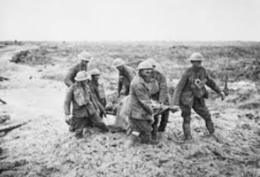The Western Front

During WW1 much of the fighting took place in Western Europe. The countryside was blasted, bombed and fought over repeatedly. Previously beautiful landscapes turned to mud; bleak and barren scenes where nothing could grow.

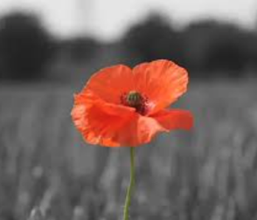Fields of Poppies

There was a notable and striking exception to the bleakness – the bright red Flanders poppies. These resilient flowers flourished in the middle of so much chaos and destruction, growing in the thousands upon thousands.

## **Armistice** means an agreement to end the fighting of the First World War as a prelude to peace negotiations. It began at 11am on 11 November 1918. (Armistice is Latin for to stop.) To this day we mark Armistice Day around the United Kingdom with a [**Two Minute Silence**](https://www.britishlegion.org.uk/stories/two-minute-silence) at 11am on the 11th day of the 11th month.

## **At the eleventh hour on the eleventh day of the eleventh month – we will remember them.**

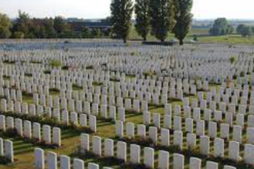We will remember not only those who died in World War 1 but also World War 2. Since the end of World War Two in 1945, British military forces have been almost constantly engaged in combat operations around the world. From post war occupations, to colonial conflicts, the Cold War against the communists, to today’s wars against Islamic Jihadists, the British military has engaged Britain’s foes.

**Today’s conflicts**

At any time there is a conflict taking place somewhere in the world. Weapons are far more destructive now and great numbers of civilians are killed along with the military.

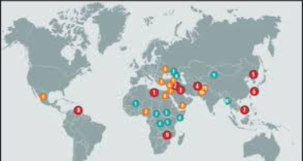This map shows some of the places where conflicts are taking place now.

We pray for peace throughout the world, particularly in Ukraine, Sudan, Israel and Gaza.