NOTICES

THE FAMILY FLOWER for July has been donated by Dorothy Dowse, remembering dear Peter who would have been 90 years old this month.

AUGUST SERVICES There are no Sunday 8am and Wednesday 9.30 services during August.

HOLIDAY CLUB Our Holiday Club this year is on 26th, 27th and 28th July for children aged 5-10. If you would like to help in any capacity please speak to Barbara.
We are looking forward to the Holiday Club but we need your help to collect a few items: large boxes eg appliance boxes, Amazon boxes etc, kitchen towel holders.

CHURCH BRASS Many regular tasks have not been done in the last two years owing to Covid. Usually our brass is cleaned before Easter but this hasn’t been done and it is clearly in need of cleaning. Please see David for a time if you can help.

THE TOWER IS FINISHED
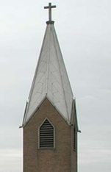
As the scaffold is now down, thank you to all those who have supported this huge project. There is still time to contribute.
You can do this through a bank transfer (details below - please use the transfer reference “Spire”) or make a cash donation in a yellow envelope in the pew (marking the envelope “Spire Fund”) and fill in your details. Thank you.

SALISBURY CATHEDRAL VISIT The visit is on 8th September, do come and join us for a great day out. Please sign the list if your name is not already on it. See back of church for details.

BECOME A HOST AND OWNER IN CHURCH The church is run by great teams of volunteers who cheerfully contribute time and talent. The teams need new people. Even if you are new to the church you are welcome to join a team and contribute. You become an owner and a host when you do that, and you will also get to know more people and gain a greater sense of belonging. Some of the tasks require only one hour of your time four times a year and some admin work can be done from your home. Happy to find out details before deciding? then speak to the Vicar Lyndon or Wardens Kemi or Gary.

S^{t} Andrew's Church bank details for one-off payments and gifts -
PCC of St Andrew's Roxbourne Parish
Sort code: 40-11-58 Acc No: 20404810
Please note this is not the account for regular Stewardship Giving - please see Wendy Godwin or Peter Sage for those details (Tel: 07889 249500

S^{T} ANDREW'S CHURCH, ROXBOURNE
89 Malvern Avenue Harrow HA2 9ER.
020 8422 3633 www.standrewsroxbourne.org.uk
Registered Charity No. 1131727

Star Link

SUNDAY, 31st JULY Seventh Sunday After Trinity
 |  |  | Roxbournestandrews
8.00 am: Holy Communion
10.00 am: Parish Communion
and Children’s Church
Please come to the Hall after the Service for Coffee, Tea & Fellowship

This Week’s Services |  | Next Sunday 7th August
Monday – Friday  9.00 am Morning Prayer [cw] |  | 10.00 am: Parish Communion  Isaiah 1.10-20; Hebrews 11.1-3 & 8-16;  Luke 12.32-40
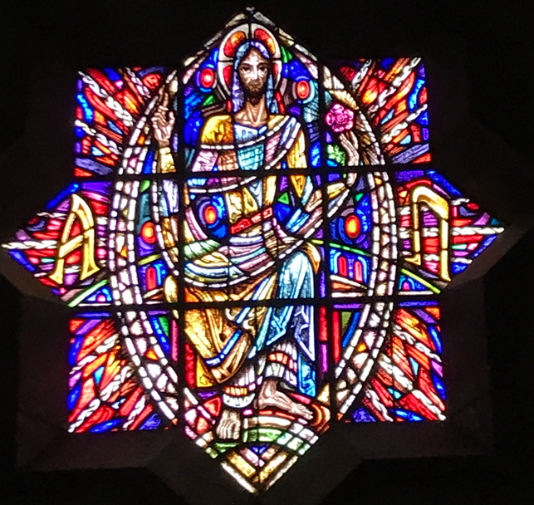

TODAY’S COLLECT

Generous God, you give us gifts and make them grow: our faith is small as mustard seed, make it grow to your glory and the flourishing of your kingdom; through Jesus Christ our Lord. Amen

TODAY’S READINGS
Hosea 11.1-11
“When Israel was a child, I loved him, and out of Egypt I called my son. But the more they were called, the more they went away from me. They sacrificed to the Baals and they burned incense to images. It was I who taught Ephraim to walk, taking them by the arms but they did not realise it was I who healed them. I led them with cords of human kindness, with ties of love. To them I was like one who lifts a little child to the cheek, and I bent down to feed them. “Will they not return to Egypt and will not Assyria rule over them because they refuse to repent? A sword will flash in their cities; it will devour their false prophets and put an end to their plans. My people are determined to turn from me. Even though they call me God Most High, I will by no means exalt them. “How can I give you up, Ephraim? How can I hand you over, Israel? How can I treat you like Admah? How can I make you like Zeboyim? My heart is changed within me; all my compassion is aroused. I will not carry out my fierce anger, nor will I devastate Ephraim again. For I am God, and not a man— the Holy One among you. I will not come against their cities. They will follow the Lord; he will roar like a lion. When he roars, his children will come trembling from the west. They will come from Egypt, trembling like sparrows, from Assyria, fluttering like doves. I will settle them in their homes,” declares the Lord.

Colossians 3.1-11
Since, then, you have been raised with Christ, set your hearts on things above, where Christ is, seated at the right hand of God. Set your minds on things above, not on earthly things. For you died, and your life is now hidden with Christ in God. When Christ, who is your life, appears, then you also will appear with him in glory. Put to death, therefore, whatever belongs to your earthly nature: sexual immorality, impurity, lust, evil desires and greed, which is idolatry. Because of these, the wrath of God is coming. You used to walk in these ways, in the life you once lived. But now you must also rid yourselves of all such things as these: anger, rage, malice, slander, and filthy language from your lips. Do not lie to each other, since you have taken off your old self with its practices and have put on the new self, which is being renewed in knowledge in the image of its Creator. Here there is no Gentile or Jew, circumcised or uncircumcised, barbarian, Scythian, slave or free, but Christ is all, and is in all.

Luke 12.13-21
Someone in the crowd said to him, ‘Teacher, tell my brother to divide the family inheritance with me.’ But he said to him, ‘Friend, who set me to be a judge or arbitrator over you?’ And he said to them, ‘Take care! Be on your guard against all kinds of greed; for one’s life does not consist in the abundance of possessions.’ Then he told them a parable: ‘The land of a rich man produced abundantly. And he thought to himself, “What should I do, for I have no place to store my crops?” Then he said, “I will do this: I will pull down my barns and build larger ones, and there I will store all my grain and my goods. And I will say to my soul, Soul, you have ample goods laid up for many years; relax, eat, drink, be merry.” But God said to him, “You fool! This very night your life is being demanded of you. And the things you have prepared, whose will they be?” So it is with those who store up treasures for themselves but are not rich towards God.’

POST-COMMUNION PRAYER
Lord God, whose Son is the true vine and the source of life, ever giving himself that the world may live: may we so receive within ourselves the power of his death and passion that, in his saving cup, we may share his glory and be made perfect in his love; for he is alive and reigns, now and for ever. Amen

PRAYER DIARY

We remember with thanksgiving the anniversary of: John Yates (4th).

Prayer requested for healing and other needs: Ralph Bedford; Robinson and Robina Ihesiene; John Jeffers; Pearl Marcano; Melanie Rudder; Pam Storey; Michael Scott – Kerr; Baby Matthew; Christopher.

Happy Birthday to: Enzo Carraro (1st); Alestir Smith (5th); Ros Williams (6th).

Congratulations to: Elizabeth and Allan Tinsley who were married on 06.08.1966 and Phillip and Marita Brown who were married on 01.08.1981. May both couples have a happy day together and many more to follow.

Wedding Day: The wedding of Georgia Wood and John Ellerbeck is taking place here on Saturday 6th August at 2pm. Our best wishes for their future.

The Parish: Our Local Schools: Alexandra Special; Heathlands; Moriah Jewish; Newton Farm; Rooks Heath; Roxbourne.

Church Families: Alan, Marina, Edward and Elizabeth Tinsey; Karen Titmuss; Sheila Tucker; Christopher and Marian Twentyman.

PRAYER FOR THE WEEK

Here I am, Lord; wounded, worried, divided against myself.
Here I am, Lord; naked, numb, exposed to you.
Here I am, Lord; held, healed, loved, passive in the arms of my God.

