NOTICES
SUNDAY LUNCH Make the first Sunday of the month St Andrew’s lunch. We
meet at The Ascott in Field End Road at 12 midday for a traditional Sunday lunch (or
whatever you fancy from the menu). This is open to all and the next date is Sunday 6th February. Please tell either of us if you are coming so we can book a table large enough.
Paul Hart, Susan McLeod
LENT APPEAL If you have a charity you would like St Andrew’s to support this year as our Lent Appeal please let Kemi, Gary or Lyndon know. We prefer to support Christian charities.

NEW YEAR, NEW START

ST. ANDREW’S is a beautiful church and to keep it so takes money and labour. We will spend a lot this year to repair our spire along with the normal maintenance and to keep it looking so good needs cleaners, gardeners and flower arrangers. How can you help?

THE LOCAL COMMUNITY St Andrew’s serves the local community with Little Steps (pre-school), Children’s Church, the Youth Club and Star Friends (senior citizens). How can you help?

SERVICE ROTA St Andrew’s, like all charitable organisations relies on its volunteers to run it. Each service has Servers, Sidespersons, Readers and Intercessions, that’s at least 10 volunteers every service. How can you help?

COFFEE ROTA Please join our coffee rota and keep our after-church fellowship going, see Judi or Kemi if you can help.

DATES FOR YOUR DIARY
Next Messy Church: Saturday 12th February
Ash Wednesday: 2nd March 2022

S^{t} Andrew's Church bank details for one-off payments and gifts -
PCC of St Andrew's Roxbourne Parish
Sort code: 40-11-58 Acc No: 20404810
Please note this is not the account for regular Stewardship Giving - please see Wendy Godwin or Peter Sage for those details (Tel: 07889 249500
Please send any items for next week’s STARLINK to Susan McLeod by midday this Friday, preferably by email (mcleod383@btinternet.com), or otherwise by hard copy to 8, Drake Road.
S^{T} ANDREW'S CHURCH, ROXBOURNE
89 Malvern Avenue Harrow HA2 9ER.
020 8422 3633 www.standrewsroxbourne.org.uk
Registered Charity No. 1131727

Star Link

SUNDAY, 16th January EPIPHANY 2

 |  |  | Roxbournestandrews
8.00 am: Parish Communion
10.00 am: Parish Communion
and Children’s Church
Please come to the Hall after the Service for Coffee, Tea & Fellowship

This Week’s Services |  | Next Sunday 23rd January
Monday – Friday  9.00 am Morning Prayer [cw]  Wednesday: 9.30am Holy Communion |  | 8.00 am: Holy Communion  10.00 am: Parish Communion  Isaiah 62:1-5; 1 Corinthians 12:1-11; John 2:1-11

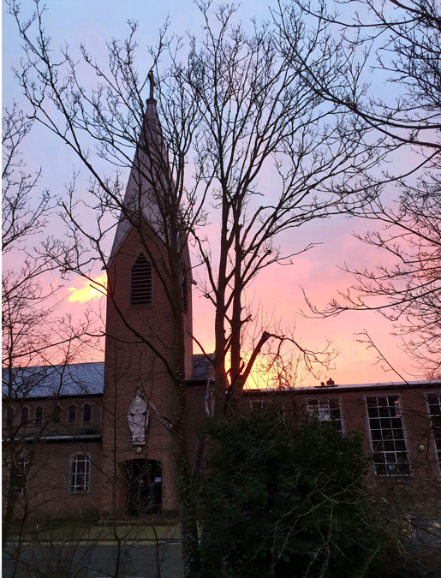
TODAY’S COLLECT
Eternal Lord, our beginning and our end: bring us with the whole creation to your glory, hidden through past ages and made known in Jesus Christ our Lord. Amen

TODAY’S READINGS
Isaiah 62:1-5
For Zion’s sake I will not keep silent, for Jerusalem’s sake I will not remain quiet, till her vindication shines out like the dawn, her salvation like a blazing torch. The nations will see your vindication, and all kings your glory, you will be called by a new name that the mouth of the Lord will bestow. You will be a crown of splendour in the Lord’s hand, a royal diadem in the hand of your God. No longer will they call you Deserted, or name your land Desolate. But you will be called Hephzibah, and your land Beulah; for the Lord will take delight in you, and your land will be married. As a young man marries a young woman, so will your Builder marry you; as a bridegroom rejoices over his bride, so will your God rejoice over you.

1 Corinthians 12:1-11
Now about the gifts of the Spirit, brothers and sisters, I do not want you to be uninformed. You know that when you were pagans, somehow or other you were influenced and led astray to mute idols. Therefore, I want you to know that no one who is speaking by the Spirit of God says, “Jesus be cursed,” and no one can say, “Jesus is Lord,” except by the Holy Spirit. There are different kinds of gifts, but the same Spirit distributes them. There are different kinds of service, but the same Lord. There are different kinds of working, but in all of them and in everyone it is the same God at work. Now to each one the manifestation of the Spirit is given for the common good. To one there is given through the Spirit a message of wisdom, to another a message of knowledge by means of the same Spirit, to another faith by the same Spirit, to another gifts of healing by that one Spirit, to another miraculous powers, to another prophecy, to another distinguishing between spirits, to another speaking in different kinds of tongues, and to still another the interpretation. All these are the work of one and the same Spirit, and he distributes them to each one, just as he determines.

John 2:1-11
On the third day there was a wedding in Cana of Galilee, and the mother of Jesus was there. Jesus and his disciples had also been invited to the wedding. When the wine gave out, the mother of Jesus said to him, “They have no wine.” And Jesus said to her, “Woman, what concern is that to you and to me? My hour has not yet come.” His mother said to the servants, “Do whatever he tells you.” Now standing there were six stone water jars for the Jewish rites of purification, each holding twenty or thirty gallons. Jesus said to them, “Fill the jars with water.” And they filled them up to the brim. He said to them, “Now draw some out, and take it to the chief steward.” So they took it. When the steward tasted the water that had become wine, and did not know where it came from (though the servants who had drawn the water knew), the steward called the bridegroom and said to him, “Everyone serves the good wine first, and then the inferior wine after the guests have become drunk. But you have kept the good wine until now.” Jesus did this, the first of his signs, in Cana of Galilee, and revealed his glory; and his disciples believed in him.

POST-COMMUNION PRAYER
God of glory, you nourish us with your Word who is the bread of life: fill us with your Holy Spirit that through us the light of your glory may shine in all the world. We ask this in the name of Jesus Christ our Lord. Amen

PRAYER DIARY

We remember with thanksgiving the anniversaries of: W.Copas (18th); William Grice; Mary Odell (20th); Ethel Godwin (21st).

Prayer requested for healing and other needs: Ralph Bedford; Mel Dunscombe; Len Gray; Richard K Jones; Pearl Marcano; Pam Storey.

Happy Birthday to: Laura Jull (16th); Peter Sage (19th); Heidi North (20th); Heba Hamad (21st).

The Parish: Our Fellow Harrow United Churches; Elmfield; St. Gabriel’s Roman Catholic; Sir John Fisher Roman Catholic; St. Pauls; St. Albans; Rayners Lane Baptist; South Harrow Baptist; Roxeth Free Church.

Church Families: John and Rose Chamberlain; Vinod Danny, Sherin and Suja Jency Chandran; Ann-Marie Cunynhame; Peter and Alison Coe; Robert Crowhurst.

The Persecuted Church: South Sudan At least 28 people were killed and 57 houses burned down in an attack by Islamist extremists against a Christian community in South Sudan, in early January. The humanitarian situation is alarming as food and other property have been burned down into ashes, leaving survivors with no shelters, no food and no safe drinking water. The incident is the latest example of attacks against South Sudanese Christians by Arab Muslims from the Republic of Sudan, along the disputed border between the two countries.
PRAYER OF THE WEEK
O God who guided by a star the Wise Men to the worship of your son: lead to yourself, we pray, the wise and the great in every land, that unto you every knee may bow, and every thought be brought into allegiance; through Jesus Christ our Lord. Amen

