NOTICES
CHRISTMAS MARKET. A huge thank you to everyone who supported the market. We had a really good turn out and raised nearly £3,000. There is still a lot of bric- a -brac and books left so please take some to a charity shop and help us clear the stage. Thanks. Gill Moore

ANGEL TREE (OUR CHOSEN CHARITY FOR CHRISTMAS 2021)
Angel Tree is a Christian charity which undertakes to send a Christmas present to the children of prisoners who are unable to do this themselves. Thank you to all those who have promised to buy presents. We do not have any more requests from prisoners, but if you would like to support this Charity to expand its work, there are Gift Aid envelopes available at the back of Church. Alternately you can contribute by Bank transfer. The details are in Starlink. Please contact me if you would like any further information. Thank you.
Keith Nicholls 0208 422 6655 keithjnicholls@gmail.com

MESSY CHURCH This will take place on Saturday, December 11th, from 10 till 12. The theme will be ' Christmas'! If you would like to help in any way by running an activity, making sandwiches or cakes then please let me know. Thanks. Gill Moore

COFFEE ROTA Please join our coffee rota and keep our after-church fellowship going, see Judi or Kemi if you can help.

CAROL SERVICE This year’s candlelit service will be a traditional 9 lessons and carols and will take place on Saturday 18th December at 7.00pm. If you live in the parish, please take a poster (from the back of the Church) advertising the Carol Service to display in your window.

DATES FOR YOUR DIARY
Next Messy Church: Saturday 11th December.
Saturday 8th January
Saturday 12th February

S^{t} Andrew's Church bank details for one-off payments and gifts -
PCC of St Andrew's Roxbourne Parish
Sort code: 40-11-58 Acc No: 20404810
Please note this is not the account for regular Stewardship Giving - please see Wendy Godwin or Peter Sage for those details (Tel: 07889 249500
Please send any items for next week’s STARLINK to Susan McLeod by midday this Friday, preferably by email (mcleod383@btinternet.com), or otherwise by hard copy to 8, Drake Road.
S^{T} ANDREW'S CHURCH, ROXBOURNE
89 Malvern Avenue Harrow HA2 9ER.
020 8422 3633 www.standrewsroxbourne.org.uk
Registered Charity No. 1131727

Star Link

SUNDAY, 5th December 2nd Sunday in Advent

 |  |  | Roxbournestandrews
8.00 am: Holy Communion
10.00 am: Parish Communion
and Children’s Church
Please come to the Hall after the Service for Coffee, Tea & Fellowship

This Week’s Services |  | Next Sunday 12th December
Monday – Friday  9.00 am Morning Prayer [cw]  Wednesday: 9.30am Holy Communion |  | 8.00 am: Holy Communion  10.00 am: Parish Communion  Zephaniah 3:14-20; Philippians 4:4-7; Luke 3:7-18
Amen

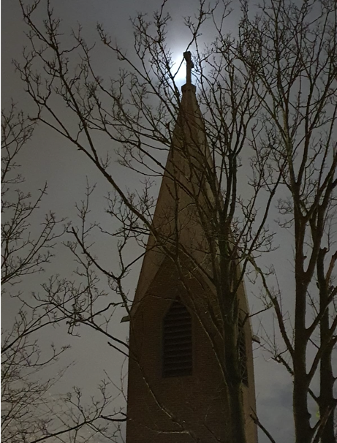

TODAY’S COLLECT
Almighty God, purify our hearts and minds, that when your Son Jesus Christ comes again as judge and saviour we may be ready to receive him, who is our Lord and our God. Amen

TODAY’S READINGS
Baruch 5:1-9
Take off the garment of your sorrow and affliction, O Jerusalem, and put on forever the beauty of the glory from God. Put on the robe of the righteousness that comes from God; put on your head the diadem of the glory of the Everlasting; for God will show your splendour everywhere under heaven. For God will give you evermore the name, "Righteous Peace, Godly Glory." Arise, O Jerusalem, stand upon the height; look toward the east, and see your children gathered from west and east at the word of the Holy One, rejoicing that God has remembered them. For they went out from you on foot, led away by their enemies; but God will bring them back to you, carried in glory, as on a royal throne. For God has ordered that every high mountain and the everlasting hills be made low and the valleys filled up, to make level ground, so that Israel may walk safely in the glory of God. The woods and every fragrant tree have shaded Israel at God's command. For God will lead Israel with joy, in the light of his glory, with the mercy and righteousness that come from him.

Philippians 1:3-11
I thank my God every time I remember you. In all my prayers for all of you, I always pray with joy because of your partnership in the gospel from the first day until now, being confident of this, that he who began a good work in you will carry it on to completion until the day of Christ Jesus. It is right for me to feel this way about all of you, since I have you in my heart and, whether I am in chains or defending and confirming the gospel, all of you share in God’s grace with me. God can testify how I long for all of you with the affection of Christ Jesus. And this is my prayer: that your love may abound more and more in knowledge and depth of insight, so that you may be able to discern what is best and may be pure and blameless for the day of Christ, filled with the fruit of righteousness that comes through Jesus Christ—to the glory and praise of God.

Luke 3:1-6
In the fifteenth year of the reign of Emperor Tiberius, when Pontius Pilate was governor of Judea, and Herod was ruler of Galilee, and his brother Philip ruler of the region of Ituraea and Trachonitis, and Lysanias ruler of Abilene, during the high priesthood of Annas and Caiaphas, the word of God came to John son of Zechariah in the wilderness. He went into all the region around the Jordan, proclaiming a baptism of repentance for the forgiveness of sins, as it is written in the book of the words of the prophet Isaiah, “The voice of one crying out in the wilderness: ‘Prepare the way of the Lord, make his paths straight. Every valley shall be filled, and every mountain and hill shall be made low, and the crooked shall be made straight, and the rough ways made smooth; and all flesh shall see the salvation of God.’”

POST-COMMUNION PRAYER
Father in heaven, who sent your Son to redeem the world and will send him again to be our judge: give us grace so to imitate him in the humility and purity of his first coming that, when he comes again, we may be ready to greet him with joyful love and firm faith; through Jesus Christ our Lord.
Amen
PRAYER DIARY

We remember with thanksgiving the anniversaries of: Ernest Perry (5th); Raymond Godwin; Michael Withey (6th); Connie Leighton (7th).

Prayer requested for healing and other needs: Roux; Ralph Bedford; Yvonne Cranmer; Mel Dunscombe; Stuart Hobbs; Richard K Jones; Pearl Marcano; Terezia Milosovicova; Jean Murch; Sylvia Pearham; Pam Storey.

Happy Birthday to: Emma Broatch (6th).

The Parish: Kings Court; Kings Road; Leamington Crescent; Lulworth Close; Lulworth Gardens; Lynton Road.

Church Families: Alan, Marina, Edward and Elizabeth Tinsey; Karen Titmuss; Sheila Tucker; Christopher and Marian Twentyman.

The Persecuted Church: Iran Good News In an amazing turnaround, Iran has decided that belonging to a house church does not make Christians ‘enemies of the state’. The country’s Supreme Court has ruled that nine Christian converts serving five-year prison sentences for going to house churches should not have been charged with ‘acting against national security’, a charge that is often made against believers in court cases.
PRAYER of the Week

O lover of the little ones, their guardian and defender; Come with your angels and cradle your children and guide their stumbling feet along the homeward roads. Amen

