NOTICES

SANCTUARY FLOWERS The flowers in the Sanctuary today have been donated by Letitia, in memory of her father Vasile Timis whose anniversary was on 16 October.

MESSY CHURCH The next Messy Church is on Saturday, October 30th from 10 till 12. The emphasis will be on LIGHT. If you would like to help run any activities, make sandwiches or cakes, please let me know. If anyone has any fairy lights that they could lend to us for the Saturday we would be very grateful. Could you also look to see whether you have any unwanted CDs we could decorate please (they catch the light beautifully when they twirl), any small, smooth glass containers that could be decorated for candle holders would be very useful as well. Please leave them at the back of the church.

ALL SOULS' MEMORIAL SERVICE: We shall be holding this Service on Sunday, 31st. October with the 10am Eucharist. If you wish to have any loved ones' name/s read, please write on the list which you will find at the back of the Church. Thank you. Enid Scott-Kerr.

BONFIRE NIGHT, NOVEMBER 5TH Help is needed this year to take money at the doors and welcome and to make tea. Please see Lyndon if you can help with this great Community Event.

CHRISTMAS MARKET It's getting closer! Please sign up on the sheets on the notice board if you would like to run a stall or have any brilliant ideas for a new stall or activity! Please have a good sort out, and any Christmas decorations, in date bottles, unwanted presents, toiletries, wrapped sweets etc please put at the back of the church and bring any books and bric a brac in November. Thank you.

DATES FOR YOUR DIARY
The Caldicott Welsh Male Voice Choir will be entertaining us on Saturday, November 13th at 7.00pm. Please sign up at the back if you’re coming.
The Christmas Market will take place on Saturday, November 20th and will include a children’s activity area.

S^{t} Andrew's Church bank details for one-off payments and gifts -
PCC of St Andrew's Roxbourne Parish
Sort code: 40-11-58 Acc No: 20404810
Please note this is not the account for regular Stewardship Giving - please see Wendy Godwin or Peter Sage for those details (Tel: 07889 249500

Please send any items for next week’s STARLINK to Susan McLeod by midday this Friday, preferably by email (mcleod383@btinternet.com), or otherwise by hard copy to 8, Drake Road.
S^{T} ANDREW'S CHURCH, ROXBOURNE
89 Malvern Avenue Harrow HA2 9ER.
020 8422 3633 www.standrewsroxbourne.org.uk
Registered Charity No. 1131727

Star Link

SUNDAY, 17th October 2021 TRINITY 20

 |  |  | Roxbournestandrews
8.00 am: Holy Communion
10.00 am: Parish Communion
and Children’s Church
Please come to the Hall after the Service for Coffee, Tea & Fellowship

This Week’s Services |  | Next Sunday 24th October
Monday – Friday  9.00 am Morning Prayer [cw]  Wednesday: 9.30am Holy Communion |  | 8.00 am: Holy Communion  10.00 am: Parish Communion  Isaiah 55:1-11,2 Timothy 3:14-4:5.John 5:36-47
Amen

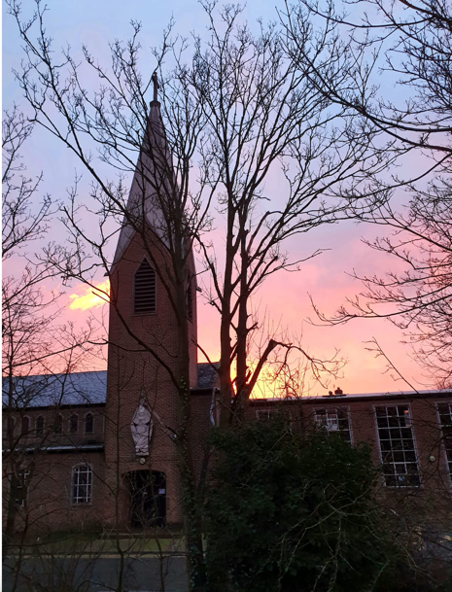
TODAY’S COLLECT
God, our light and our salvation: illuminate our lives, that we may see your goodness in the land of the living, and looking on your beauty may be changed into the likeness of Jesus Christ our Lord. Amen

TODAY’S READINGS
Job 38:1-7
Then the Lord spoke to Job out of the storm. He said: “Who is this that obscures my plans with words without knowledge? Brace yourself like a man; I will question you, and you shall answer me. “Where were you when I laid the earth’s foundation? Tell me, if you understand. Who marked off its dimensions? Surely you know! Who stretched a measuring line across it? On what were its footings set, or who laid its cornerstone— while the morning stars sang together and all the angels shouted for joy?
Hebrews 5:1-10
Every high priest is selected from among the people and is appointed to represent the people in matters related to God, to offer gifts and sacrifices for sins. He is able to deal gently with those who are ignorant and are going astray, since he himself is subject to weakness. This is why he has to offer sacrifices for his own sins, as well as for the sins of the people. And no one takes this honour on himself, but he receives it when called by God, just as Aaron was. In the same way, Christ did not take on himself the glory of becoming a high priest. But God said to him, “You are my Son; today I have become your Father.” And he says in another place, “You are a priest forever, in the order of Melchizedek.” During the days of Jesus’ life on earth, he offered up prayers and petitions with fervent cries and tears to the one who could save him from death, and he was heard because of his reverent submission. Son though he was, he learned obedience from what he suffered and, once made perfect, he became the source of eternal salvation for all who obey him and was designated by God to be high priest in the order of Melchizedek.
Mark 10:35-45
James and John, the sons of Zebedee, came forward to him and said to him, “Teacher, we want you to do for us whatever we ask of you.” And he said to them, “What is it you want me to do for you?” And they said to him, “Grant us to sit, one at your right hand and one at your left, in your glory.” But Jesus said to them, “You do not know what you are asking. Are you able to drink the cup that I drink, or be baptized with the baptism that I am baptized with?” They replied, “We are able.” Then Jesus said to them, “The cup that I drink you will drink; and with the baptism with which I am baptized, you will be baptized; but to sit at my right hand or at my left is not mine to grant, but it is for those for whom it has been prepared.” When the ten heard this, they began to be angry with James and John. So Jesus called them and said to them, “You know that among the Gentiles those whom they recognize as their rulers lord it over them, and their great ones are tyrants over them. But it is not so among you; but whoever wishes to become great among you must be your servant, and whoever wishes to be first among you must be slave of all. For the Son of Man came not to be served but to serve, and to give his life a ransom for many.”

POST-COMMUNION PRAYER
God our Father, whose Son, the light unfailing, has come from heaven to deliver the world from the darkness of ignorance: let these holy mysteries open the eyes of our understanding that we may know the way of life, and walk in it without stumbling; through Jesus Christ our Lord. Amen

PRAYER DIARY

RIP: Joan Rhoades, Sir David Amess who have died recently.

We remember with thanksgiving the anniversaries of: Jill Maynard (22nd); Malcolm Blanch; Louise Greyson (23rd).

Prayer requested for healing and other needs: Ralph Bedford; Anne –Marie Cunyhame; Jim Field; Stuart Hobbs; Richard K Jones; Kapilan: Delia, Maria and Daniel Kepinski; Pearl Marcano; Jean Murch; Andrew Phelps; Michael Scott-Kerr Pam Storey; Barbara Wood.

Happy Birthday to: Robert Bendall (14th); Rev. Lyndon North (15th); Audvik Gupta (19th).

The Parish: Mirren Close; Newlyn Gardens; Newquay Crescent; Ovesdon Avenue; Pembroke Avenue; Perwell Avenue.

Church Families: Robinson and Robina Ihesiene; Nemo Isaac; Ratnasapathy and Nerhu Janagan; Sue and Ian Jull; Sunhyun, Gwon, Yedami Jung; Michael James.

The Persecuted Church: Lebanon: “Now that Christmas is approaching, families are not even worrying about if they can buy nice gifts for their children – their fears are more basic, that they won’t even be able to provide a home or food by that time.” – The words of a Lebanese Christian leader this week. Many people in the areas most impacted by last year’s explosion at the port of Beirut do not yet have proper windows or doors in their damaged houses. The majority of them are Christian. Keeping warm this winter will be more difficult than ever.

PRAYER of the Week
We thank you, O God, for the saints of all ages; for those who, in times of darkness, kept the lamp of faith burning; for the great souls who saw visions of larger truth and dared to declare it; for the multitude of quiet and gracious souls whose presence has purified and sanctified the world; and for those we knew and loved, who have passed from this earthly fellowship into the fuller light of life with you.

