NOTICES

FAMILY FLOWERS The family flower for June has been donated by Pam Storey in loving memory of Michael Storey and of her parents, Gwen and Bill Judge.

BIG BREKKIE Thanks to all those who have helped today with the Big Brekkie.

WINCHESTER CATHEDRAL We are planning a visit to Winchester Cathedral in September when we hope all Covid restrictions are gone and the weather will be better. Please take a handout with all the information and sign up on the sheet at the back of the church.

CELEBRATION SUNDAY Join us on Sunday 27th June (we hope) to celebrate the ending of Coronavirus restrictions and the return to normality with music, drinks and a barbecue. Please put your name on the list at the back of the church so we have an idea of numbers.
If you can contribute to the food by making a salad or a dessert we will be grateful. And yes, there is another list to sign!

SAVE OUR BELL TOWER is a special fund that has been set up to fund the repairs to the tower which are being carried out later in the year.

S^{t} Andrew's Church bank details for one-off payments and gifts -
PCC of St Andrew's Roxbourne Parish
Sort code: 40-11-58 Acc No: 20404810
Please note this is not the account for regular Stewardship Giving - please see Wendy Godwin or Peter Sage for those details (Tel: 07889 249500

PRAYER FOR THE WEEK

O God, you are the one to whom I reach out, mystery beyond human thinking, love beyond comprehending. Yet because you are love, you have reached out to me, joined me to Christ, taken me into the very heart of your divine life, come close to me as father and brother, and even more You yourself have to dwell in me, so it is your love within me reaching out to your love beyond me. O God beyond me, God besides me, God within me.

Please send any items for next week’s STARLINK to Susan McLeod by midday this Friday, preferably by email (mcleod383@btinternet.com), or otherwise by hard copy to 8, Drake Road.
S^{T} ANDREW'S CHURCH, ROXBOURNE
89 Malvern Avenue Harrow HA2 9ER.
020 8422 3633 www.standrewsroxbourne.org.uk
Registered Charity No. 1131727

Star Link

SUNDAY, 13th June 2021 Trinity 2
 |  |  | Roxbournestandrews
8.00 am: Holy Communion
10.00 am: Parish Communion
and Go Mad on Sunday

This Week’s Services |  | Next Sunday 20th June
Monday – Friday  9.00 am Morning Prayer [cw]  Wednesday: 9.30am Holy Communion |  | 8.00 am: Holy Communion  10.00 am: Parish Communion  1 Samuel 17:32-49; 2 Corinthians 6:1-13;  Mark 4:35-41
Amen

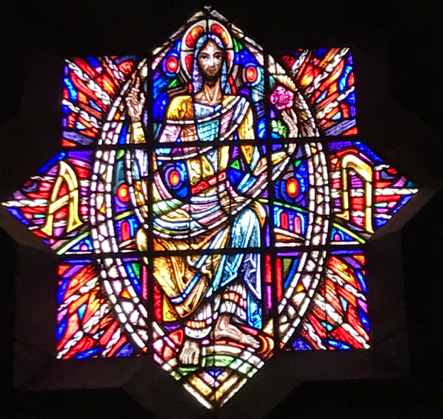
TODAY’S COLLECT
Faithful Creator, whose mercy never fails: deepen our faithfulness to you and to your living Word, Jesus Christ our Lord. Amen

1 Samuel 15:34-16:13
The Lord said to Samuel, “How long will you mourn for Saul, since I have rejected him as king over Israel? Fill your horn with oil and be on your way; I am sending you to Jesse of Bethlehem. I have chosen one of his sons to be king.” But Samuel said, “How can I go? If Saul hears about it, he will kill me.” The Lord said, “Take a heifer with you and say, ‘I have come to sacrifice to the Lord.’ Invite Jesse to the sacrifice, and I will show you what to do. You are to anoint for me the one I indicate.” Samuel did what the Lord said. When he arrived at Bethlehem, the elders of the town trembled when they met him. They asked, “Do you come in peace?” Samuel replied, “Yes, in peace; I have come to sacrifice to the Lord. Consecrate yourselves and come to the sacrifice with me.” Then he consecrated Jesse and his sons and invited them to the sacrifice. When they arrived, Samuel saw Eliab and thought, “Surely the Lord’s anointed stands here before the Lord.” But the Lord said to Samuel, “Do not consider his appearance or his height, for I have rejected him. The Lord does not look at the things people look at. People look at the outward appearance, but the Lord looks at the heart.” Then Jesse called Abinadab and had him pass in front of Samuel. But Samuel said, “The Lord has not chosen this one either.” Jesse then had Shammah pass by, but Samuel said, “Nor has the Lord chosen this one.” Jesse had seven of his sons pass before Samuel, but Samuel said to him, “The Lord has not chosen these.” So he asked Jesse, “Are these all the sons you have?” “There is still the youngest,” Jesse answered. “He is tending the sheep.” Samuel said, “Send for him; we will not sit down until he arrives.” So he sent for him and had him brought in. He was glowing with health and had a fine appearance and handsome features. Then the Lord said, “Rise and anoint him; this is the one.” So Samuel took the horn of oil and anointed him in the presence of his brothers, and from that day on the Spirit of the Lord came powerfully upon David. Samuel then went to Ramah.

2 Corinthians 5:6-10
Therefore we are always confident and know that as long as we are at home in the body we are away from the Lord. For we live by faith, not by sight. We are confident, I say, and would prefer to be away from the body and at home with the Lord. So we make it our goal to please him, whether we are at home in the body or away from it. For we must all appear before the judgment seat of Christ, so that each of us may receive what is due us for the things done while in the body, whether good or bad.

Mark 4:26-34
He also said, “The kingdom of God is as if someone would scatter seed on the ground, and would sleep and rise night and day, and the seed would sprout and grow, he does not know how. The earth produces of itself, first the stalk, then the head, then the full grain in the head. But when the grain is ripe, at once he goes in with his sickle, because the harvest has come.” He also said, “With what can we compare the kingdom of God, or what parable will we use for it? It is like a mustard seed, which, when sown upon the ground, is the smallest of all the seeds on earth; yet when it is sown it grows up and becomes the greatest of all shrubs, and puts forth large branches, so that the birds of the air can make nests in its shade.” With many such parables he spoke the word to them, as they were able to hear it; he did not speak to them except in parables, but he explained everything in private to his disciples.
POST-COMMUNION PRAYER
Loving Father, we thank you for feeding us at the supper of your Son: sustain us with your Spirit, that we may serve you here on earth until our joy is complete in heaven, and we share in the eternal banquet with Jesus Christ our Lord. Amen

PRAYER DIARY
We remember with thanksgiving the anniversaries of: Ethel Udall; Charles Austin; Emma Robinson (15th).

Prayer requested for healing and other needs: Ralph Bedford; Marita Brown; Stuart Hobbs; Robinson and Robina Ihesiene; Pearl Marcano; Jean Murch; Marion Perry; Andrew Phelps; Pam Storey; Michael Scott-Kerr; Elizabeth Tinsey; Avice Wright.

Happy Birthday to: Chris Robins (18th).

Church Families: Youngmi, Jounhoon, Suhyung, Taeyang Kwon.

The Parish: Rayners Lane; Raynton Close; Rosebery Avenue; Rowe Walk; Somervell Road; Spinnells Road; Sterling Avenue; Stiven Crescent; Stradbrook Close.

The Persecuted Church: Pakistan Last year the blasphemy laws continued to be widely misused against Christians and other minorities – often to settle personal scores. In addition, the abduction, rape, and enforced conversion and marriage of Christian girls are reported. In fact, Pakistan’s Christians are likely to face oppression and discrimination throughout their lives: at work, at school and college, in accessing services and resources, and in the legal system. So persecution will continue through 2021.

