**NOTICES**

**FLOWERS** The Family flower in St. Stephen’s Chapel for **August** has been given by Sue Brown in loving memory of her mum, Kathleen Taylor.

**AUGUST** There will be no **8am services** throughout the month of **August.**

There will be no **Wednesday services** in **August.**

There will be no **Children’s Church** in **August.**

We all deserve a break and will return in September with renewed energy

**QUIZ EVENING** Come to our next social event, the Quiz Evening on **Saturday 4th October**. Bring a team or just turn up and join one. They are always good fun.

**HARROW FOOD BANK CONTAINER:** Is still in operation. Please give your contributions to Lyndon, Enid or David. You may also leave it in a bag at the back of the church. We will store it away daily until collection day. We have a small problem which we are trying to address.  *David Alleyne*

**ST. PAUL’S CATHEDRAL** Why not go up to town and pay a visit to St. Paul’s Cathedral? We have 4 free entry cards which can be used at any time. See me and I will pass them to you, but do remember to return them for the next person to use  *Susan McLeod*

1. St Andrew's Church bank details for one-off payments and gifts -
2. **PCC of St Andrew's Roxbourne Parish**
3. **Sort code: 40-11-58  Acc No: 20404810**
4. *Please note this is not the account for regular Stewardship Giving - please see Wendy Godwin or Peter Sage for those details (Tel: 07889 249500*

**Prayer for the week**

Living Lord, we thank you for your love so freely given to us all. We pray for families around the world. Bless the work of the Mothers Union as we seek to share your love through the encouragement, strengthening and support of marriage and family life. Empowered by your spirit, may we be united in prayer and worship and in love and service, reach out your hands across the world. In Jesus name. Amen.

**ST ANDREW'S CHURCH, ROXBOURNE**

|  |  |  |
| --- | --- | --- |
| *STAR LOGO 4* | **89 Malvern Avenue Harrow HA2 9ER.**  **020 8422 3633 www.standrewsroxbourne.org.uk**  **Registered Charity No. 1131727** |  |

***Star Link***

|  |  |  |  |
| --- | --- | --- | --- |
|  | | | |
| **SUNDAY, 10th AUGUST TRINITY 8**  **Welcome to Rev Irene Lawrence, today’s celebrant** | | | |
|  | | | Roxbournestandrews |
|  | | |
|  | | |
| **10.00 am: Parish Communion**  **with Prayers for Healing**  *Please come to the Hall after the Service for Coffee, Tea & Fellowship* | | |
| **This Week’s Services** |  | **Next Sunday 17thAugust** | |
| **Monday – Friday 9am Morning Prayer** |  | **10.00 am: Parish Communion**  *Isaiah 5: 1-7; Hebrews 11: 29-ch.12:2;*  *Luke 12: 49-56* | |
|  |

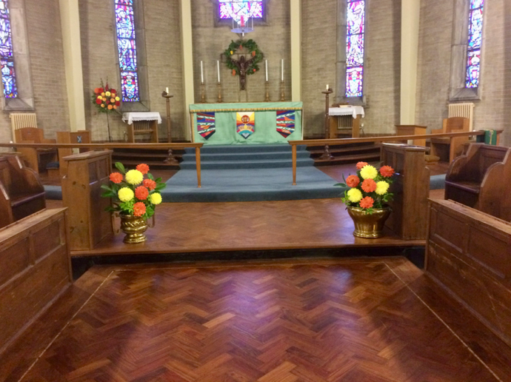

TODAY’S COLLECT

**Lord God, your Son left the riches of heaven and became poor for our sake: when we prosper save us from pride, when we are needy save us from despair, that we may trust in you alone; through Jesus Christ our Lord. Amen**

TODAY’S READINGS

***Isaiah 1: 1 & 10-20***

The vision concerning Judah and Jerusalem that Isaiah son of Amoz saw during the reigns of Uzziah, Jotham, Ahazand Hezekiah, kings of Judah.

Hear the word of the Lord, you rulers of Sodom; listen to the instruction of our God, you people of Gomorrah!“The multitude of your sacrifices— what are they to me?” says the Lord. “I have more than enough of burnt offerings, of rams and the fat of fattened animals; I have no pleasure in the blood of bulls and lambs and goats.When you come to appear before me, who has asked this of you, this trampling of my courts? Stop bringing meaningless offerings! Your incense is detestable to me. New Moons, Sabbaths and convocations— I cannot bear your worthless assemblies. Your New Moon feasts and your appointed festivals I hate with all my being. They have become a burden to me; I am weary of bearing them.When you spread out your hands in prayer, I hide my eyes from you; even when you offer many prayers, I am not listening. Your hands are full of blood!Wash and make yourselves clean. Take your evil deeds out of my sight; stop doing wrong.Learn to do right; seek justice. Defend the oppressed. Take up the cause of the fatherless; plead the case of the widow.“Come now, let us settle the matter,” says the Lord. “Though your sins are like scarlet, they shall be as white as snow; though they are red as crimson, they shall be like wool.If you are willing and obedient, you will eat the good things of the land;but if you resist and rebel, you will be devoured by the sword.” For the mouth of the Lord has spoken.

***Hebrews 11: 1-3 & 8-16***

Now faith is confidence in what we hope for and assurance about what we do not see. This is what the ancients were commended for.By faith we understand that the universe was formed at God’s command, so that what is seen was not made out of what was visible. By faith Abraham, when called to go to a place he would later receive as his inheritance, obeyed and went, even though he did not know where he was going. By faith he made his home in the promised land like a stranger in a foreign country; he lived in tents, as did Isaac and Jacob, who were heirs with him of the same promise. For he was looking forward to the city with foundations, whose architect and builder is God. And by faith even Sarah, who was past childbearing age, was enabled to bear children because sheconsidered him faithful who had made the promise. And so from this one man, and he as good as dead, came descendants as numerous as the stars in the sky and as countless as the sand on the seashore.All these people were still living by faith when they died. They did not receive the things promised; they only saw them and welcomed them from a distance, admitting that they were foreigners and strangers on earth. People who say such things show that they are looking for a country of their own. If they had been thinking of the country they had left, they would have had opportunity to return. Instead, they were longing for a better country—a heavenly one. Therefore God is not ashamed to be called their God, for he has prepared a city for them.

***Luke 12: 32-40***

‘Do not be afraid, little flock, for it is your Father’s good pleasure to give you the kingdom. Sell your possessions, and give alms. Make purses for yourselves that do not wear out, an unfailing treasure in heaven, where no thief comes near and no moth destroys. For where your treasure is, there your heart will be also.‘Be dressed for action and have your lamps lit; be like those who are waiting for their master to return from the wedding banquet, so that they may open the door for him as soon as he comes and knocks. Blessed are those slaves whom the master finds alert when he comes; truly I tell you, he will fasten his belt and have them sit down to eat, and he will come and serve them. If he comes during the middle of the night, or near dawn, and finds them so, blessed are those slaves.‘But know this: if the owner of the house had known at what hour the thief was coming, he would not have let his house be broken into. You also must be ready, for the Son of Man is coming at an unexpected hour.’

**POST COMMUNION PRAYER**

**Strengthen for service, Lord, the hands that have taken holy things; may the ears which have heard your word be deaf to clamour and dispute; may the tongues which have sung your praise be free from deceit; may the eyes which have seen the tokens of your love shine with the light of hope; and may the bodies which have been fed with your body be refreshed with the fullness of your life; glory to you for ever. Amen**

**PRAYER DIARY**

**RIP:** John Bedford who died on 30th September.

**The Parish** Ovesdon Avenue, Pembroke Avenue, Perwell Avenue, Perwell Court, Primrose Close, Ravenswood Crescent, Rayners Lane, Rayton Close, Rosebury Avenue.

**Happy Birthday to** Stephanie Lawrence (10th), Diane Bidder, Emily Morshonga (12th), Rev.Anna Dias (13th),Solomon Wong (14th),Keira Grice (15th), Miroa Subasinghe (6th).

**This week we remember with thanksgiving the anniversaries of:** Diane Sonuga (10th), William Nicholay (13th), Beryl Crowhurst (14th), Kathleen Taylor, David Hughes (15th), Joyce Lemar (16th).

**Prayer request for healing and other needs** Earl Adams, David Alleyne, Ralph Bedford, Mark Gardiner, Malcolm George, Broden Kiely, Emily Rockingham, Pam Storey, Martin Vowles, Angela Zadurian.

**Church Families:** Eriabu & Annie Nakabale, Keith & Sue Nicholls, Joyce Nicholay, Chris Netsel, Pam Quatermaine.

**Congratulations to:** Roger & Gill Moore who were married on 14th August 1971. May they have a happy day together and many more to come.