Messy Church - Easter 2021
Welcome to our Easter activities Part One
Our story begins on Palm Sunday, which is the beginning of Holy Week, the last week before Jesus died.
All the colouring, crafts and activities can be downloaded these are:
- Palm Sunday and Holy Week Story Book and Picture Matching
- Games and Activities including Find the Donkey, Palm craft and Memory Verse
- Lots of sheets for you to colour which tell the Holy Week story

Also, we have some suggestions for crafts that you can make from things you have at home.
Craft ideas
1. Make a cross out of playdough (recipe at the end
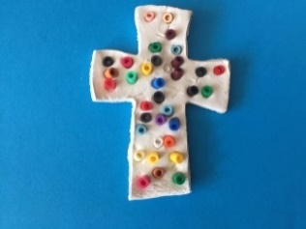
unless you have an activity bag where clay is included).
and decorate with twigs, stones, beads or buttons
Think about how Jesus died on the cross so that we could be forgiven for the things we do wrong.

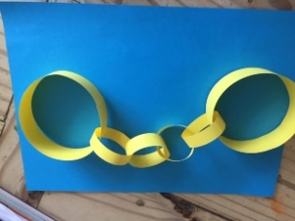
- Make some handcuffs out of paper
Imagine how Jesus must have felt when he was arrested

3. Gather together things to retell the Easter story.
You can use Lego people or make peg people for the characters.
You can use paper to make palm leaves for Palm Sunday.
Use some bricks to make a table for the Last supper and put 13 figures around it (Jesus was there with his 12 special friends).
Make flowers and gather some twigs and leaves for the Garden of Gethsemane.
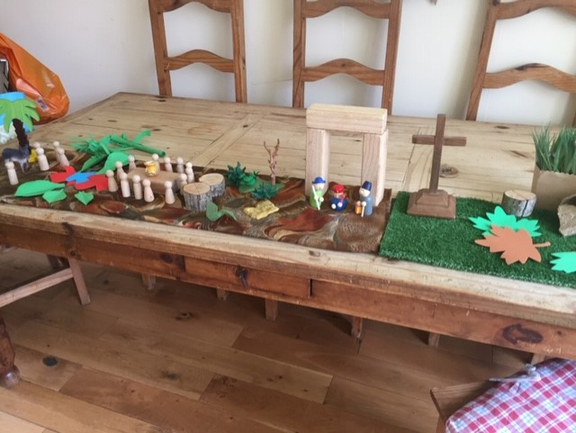
Use some Lego or blocks of woods to make the court for the trial of Jesus Use a cross or make one from twigs or sticks to remind us Jesus died.
Then flowers for the garden where Jesus body was put with a flowerpot as a tomb or an egg box using just one egg holder and a stone rolled away. This is what I did

To think about:
When Jesus had his Last Supper with his friends, he broke some bread and said, ‘this is my body broken for you’.
Then, he drank some wine and said, ‘This is my blood shed for you’.
What do you think Jesus meant when he said this?
Jesus went to the Garden of Gethsemane to pray.
He asked three of his disciples who were with him Peter, James and John to stay awake, but they couldn’t, and they fell asleep.
How do you think Jesus felt?
One of Jesus’ friends betrayed him to people who didn’t like Jesus and he was arrested even though he had done nothing wrong.
Have you ever had a time when you were treated unfairly? (maybe put on the handcuffs if you have made them and imagine how Jesus felt).
Jesus was crucified on a cross on Good Friday.
That may not seem good to us, but because Jesus died all the things, we do wrong are forgiven by God and we can be friends with him.
Coming Next – Part Two - The Wonderful Story of Easter

Below – Playdough recipe
Playdough recipe
1 cup flour (if you can get it!)
½ cup salt
2 teaspoons cream of tartar
1 cup water
2 tablespoons oil
Food colouring
· Combine flour, salt and tartar in pan.
· Gradually stir in water mixed with oil and colouring.
· Keep mixing and stirring on medium heat until mixture becomes dry.
· Remove from heat allow to cool and knead well.

