St. Andrew’s Church
89, Malvern Avenue, South Harrow, Middlesex. HA2 9ER Registered Charity No. 1131727

Regulations for occasional hall hirers

Please respect our halls as they are costly to maintain. Our guidelines and regulations to help you are listed below.

- The Church Halls are under the control of the Estate Management Committee of the Parochial Church Council in conjunction with the Vicar and Churchwardens.

Bookings for weekday hire are made with the Church Secretary whose office is to the right-hand side of the Vicarage. Tel: (020) 8422 3633 Tuesday, Wednesday, Thursday 9.30 am to 12.30 pm

Bookings for weekend hire are made with the Hall Letting Secretary -
Annie Dawson Mobile: 075 78 78 90 99 E-mail: starlet3633@gmail.com

- No lettings may be booked by persons under 21 years of age.

- The Large Hall (contiguous with the church) is on consecrated ground by the Church of England and no other type of worship is allowed.

- Our halls are in a residential area and consideration needs to be shown to the neighbours. Therefore, we ask you to keep the volume of music at a reasonable level (ie that it cannot be heard on the streamside of the car park). In addition, please disperse quietly and do not slam car doors when departing at the end of your event. It would also be helpful not to turn on the car radio until you are some way along the public highway.

- A completed application form together with a deposit of £200 must be sent by one of the methods specified on the Booking Form to the Hall Letting Secretaries.

- The hire charge must be paid not less than 14 days before the hire date. The security charge may be forfeited in respect of any damage to the premises or fittings, for additional cleaning, or overstaying the booking period. Please allow 14 days for return of deposit.

- The hire includes the use of available furniture, and this must be returned to its normal location ready for the next let. If the kitchen is used, please leave it clean and tidy. No additional cooking appliances may be brought on to the premises. The booked period must include any time required for setting up and clearing away.

- Party lighting (glitter ball etc.) is available by prior arrangement at the time of booking at a charge of £75. Also stage lighting is available at a charge of £25.

- Cancellation If more than 14 days’ notice of cancellation is given, one half of the deposit will be refunded. If less than 14 days, the whole deposit will be forfeited

- The Parochial Church Council cannot accept liability for any loss or damage to personal property on any part of the premises.

- The maximum number of persons allowed in the halls is:

Large Hall: 220 persons NOTE: Space will be restricted if the maximum
Youth Centre: 120 persons numbers are seated at tables

- The halls are not licensed for public entertainment. Private functions must not be advertised, and tickets must not be sold to the general public. There are requirements about playing commercially recorded music. Please see the Booking Form.

- Licensing Laws do not permit the sale of alcohol on the premises. Alcoholic drinks may be consumed at private functions. Please takeaway recyclable bottles and cans when you leave.

- The Parish of St. Andrew’s regards the safeguarding, care and protection of children and vulnerable adults with the utmost concern. Groups that hire or use the church premises are expected to share this concern and adhere to the Safeguarding Policy Statement of St. Andrew’s. This statement can be found on St. Andrew’s website: http://www.standrewsroxbourne. org.uk/

Please make appropriate provision for all people in your care and be aware that there is a stream bordering the car park and the field.

- Car parking space is limited, and is shared with other hall users and the church. Parking is not permitted on the footpath or the grass verges. Access for emergency vehicles must be maintained.

- All doors are fire exits and must not be blocked. NO SMOKING is allowed on the premises.

- All rubbish to be cleared away at the end of the let. Remember to bring your black bag/s.

- Accident Report Book: In the event of an accident this must be recorded in the Accident Report Book which is located –
Large Hall – With the First Aid Box in the Kitchen.
Youth Centre – In the Kitchen area.

- Please do not use BLUE-TACK or pin any notices or decorations on to the curtains. The curtains are new and will be inspected after each let. Compensation will be deducted from the Deposit if any damage is detected.

- Please do not stick tape to the floor or drag tables and chairs across the floor. The Large Hall floor has recently been sanded and sealed at significant expense and the Youth Centre floor was refurbished a short while ago.

- Please seek guidance from the caretaker or Hall Letting Secretaries if you wish to use the stage. There are black curtains on a circular rail which form a back drop. Do not pin any decorations on these as they have been newly installed. However, there is a drop down wooden bar in front of these curtains from which decorations can be hung.

- It is forbidden to use staples or drill holes into any of the tables. These will be inspected after each let and if damaged, appropriate compensation will be sought.

- A pictorial guide is given below for the stacking of chairs at the end of the event.

- Acceptance of these regulations is a condition of the hire. Nearly all of our hirers are very responsive and co-operative. Please do not be the odd one out.

Enjoy your function. We wish you well.

Please stack the same size chairs together facing
the columns but not covering the radiators.
Thank you.

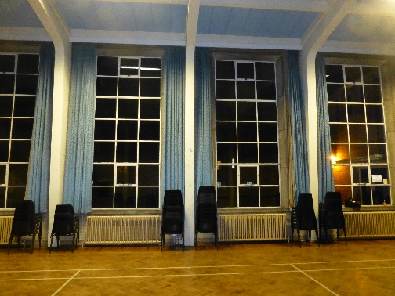

January 2020

