Christmas Messy Church 2020
Christmas is nearly here, and we are so excited to share with you the Christmas story.
This is the story of God’s love for us.
God sent His Son Jesus to be born amongst us and to live on earth as a human.
Jesus is called ‘Emmanuel’, which means God is with us.
On Christmas Day we celebrate His birthday!
We have included lots of exciting activities for you to do and the Story of Christmas for you to share.
Also, some crafts you can make from things you may have at home.
So have fun as we explore this amazing story together.
Included:
Good news for everyone (Bubbles)
Mary & Joseph cut and stick
God is with us Angel
Colouring Star
Colouring Nativity scene
Christmas wordsearch
3D Nativity scene
Fill Our Hearts with Joy Bauble (colour and cut)
Advent candles
Matchbox Manger craft (3 sheets of paper)
Nativity cut out
Crafts
3D Nativity scene
You will need felt tips, scissors, glue stick and printed template
1. Colour in the picture
2.Cut along the solid lines and then fold along the dotted line.
3.stick the 2 end pieces under the middle piece so that your picture stands up. 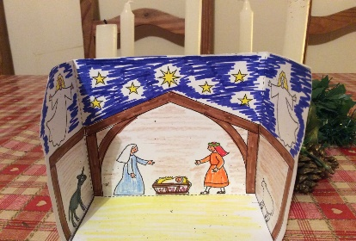
Talk about the characters in the story. Why was Jesus born in a stable?
Who do the shepherds think he is?

Advent Hat
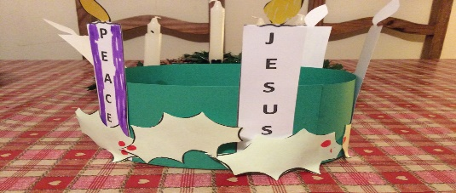
You will need some green card, printed template of candle, red paper, green paper
1.Make a head band using some green card.
2.Cut out the candles and colour 3 purple, the one with joy on it pink and leave the one for Jesus white.
3. Make some holly out of green paper or white and colour it green
4. Add some berries using the red paper.
Talk about Advent. Advent is the four weeks before Christmas it is a time of waiting and preparation.
Each candle represents something for us to reflect on. The last candle is lit on Christmas Day to celebrate the birthday of Jesus the Son of God.

Matchbox manger craft
You will need: the printed templates (you can colour them in), scissors, glue, felt tips
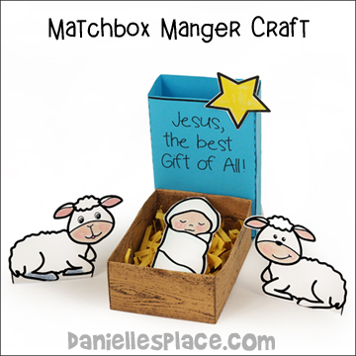
- Cut out the box bottom patterns (brown) on all the solid lines.
- Fold all the dotted lines in towards the centre of the pattern. Glue the “A” tabs together overlapping each other on each side of the box. Place glue on the tabs, fold them in and hold them together until the glue sticks.
- Cut out the top of the box, fold and glue
- Cut out Baby Jesus the star and the sheep and colour.
- Place some yellow paper in the box and carefully place Baby Jesus in his manger.
- Perhaps you can retell the story of Jesus’ birth to someone in your family.

Nativity Cut out
You will need a colour printed stable background, a printed sheet of Nativity characters, scissors, glue stick, felt tips
- Colour in all the characters
- Cut them out and stick them where you would like them to be in the stable 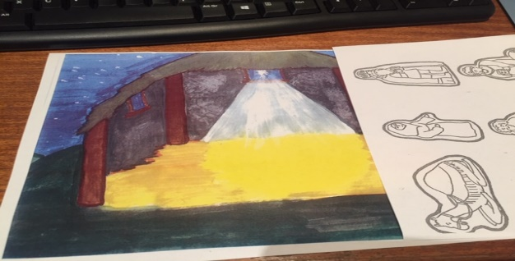
Talk about how you would have felt if you were in the stable when Jesus was born.

Father Christmas
You will need – red card, a paper plate some white card, felt tips, scissors, glue stick
1.Cut a large triangle from the red card.
2.Cut the paper plate in half and then snip into the curved edge.
3.Stick the halved paper plate just over halfway up the red triangle. Curved edge down/
4.Cut a circle from the white card and stick it on the top of the triangle. Add cotton wool if you wish.
5. Draw his face. 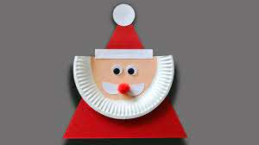add a red nose.
Paper plate Angel
You will need – a paper plate scissors, felt tips, glue stick, silver/gold/yellow tissue paper cut into small pieces, wool, white paper/card
1, Cut a triangle out of the plate and stick it on the plate with the pointy bit in the middle.
2. Cut out a circle from the white card and stick it on the pointy part on the plate.
3. Decorate your angel using the pieces of tissue, felt tips and glitter. Use the wool for the hair
Talk about how the Angel Gabriel told Mary she was going to have a baby.
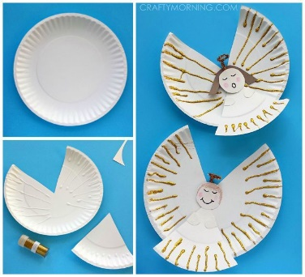

Baby Jesus
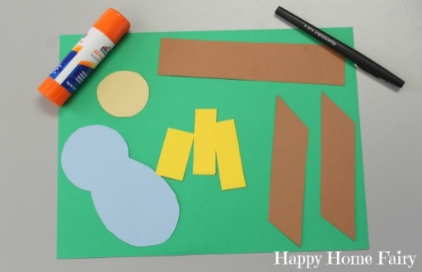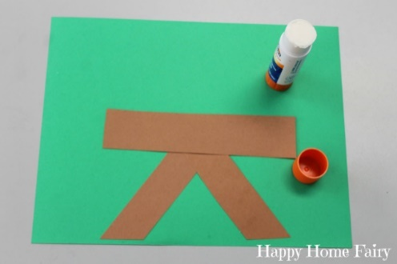
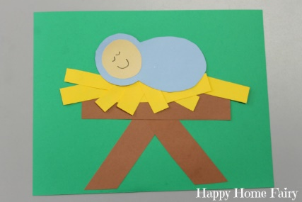
You will need brown paper, yellow paper, blue paper, white aper for Jesus face and colour it
1.First make the manger as shown
2.Add the straw and Baby Jesus. Don’t forget to draw His face.
Talk about how Jesus was placed in a manger in a stable when he was born, as there was no room in Bethlehem for Mary and Joseph.
I wonder what it was like in the stable. What do you think?

We hope you have fun!
May we wish you and your family a happy and blessed Christmas.

