Crafts and activities for Pentecost.
Please read the attached story for Pentecost and then have fun doing the activities.
Downloads
- The Story of Pentecost
- Pentecost colouring
- Pentecost wordsearch
4 Flame template for hat
5 Dove template for Holy Spirit cup craft
6. Spiral template

Crafts
- Make a hat
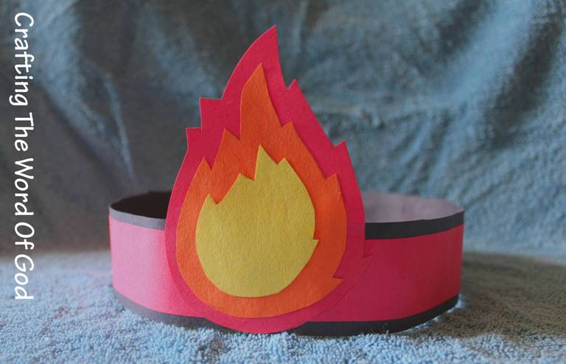
(See image) Use a piece of red card and make a band for your head. Cut a flame shape out of red, yellow and orange card in different sizes. Stick them on top of each other. Add more flames if you wish
The flames remind us of the tongues of fire that fell down on the disciples as they were filled with the Holy Spirit.

2 Make a Pentecost wind twirl

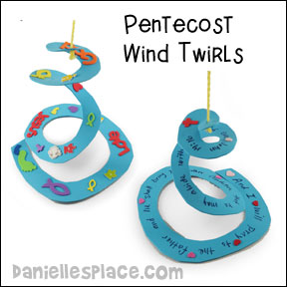

Print out the attached spiral template colour and decorate it. Then carefully cut around the lines
Attach a piece of thread to the top of the spiral and watch as the spiral moves in the wind.
This craft reminds us of the mighty wind that blew on the day of Pentecost as the Holy Spirit came down on the disciples.

Dove craft
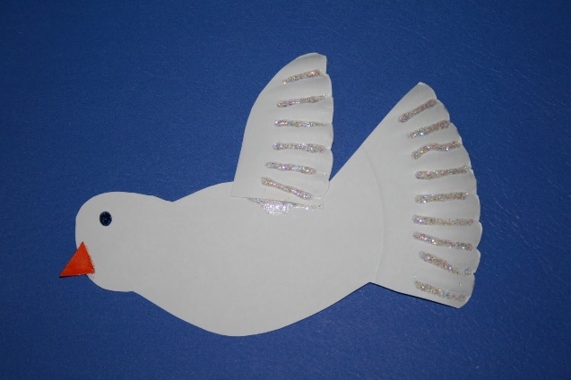

Take a paper plate and cut out a basic bird shape without wings (as in the picture).
Then cut out a wing and use some orange/yellow card for a beak and draw in an eye.
The dove is a symbol of the Holy Spirit. Decorate

How to make a mini kite
Paper - Preferably light enough to 'fly' but solid enough to hold up
2. Straws
3. Double Sided Tape – if you have it or use glue
4. String
5. Scissors

1. Cut 2 triangles. One for the kite. Another smaller one for the rudder. Cut one more tiny rectangular piece of paper for securing the kite down onto the rudder. (see picture)
2. Tape two drinking straws in a cross.
3. Tape the bigger triangle over the cross
4. Tape the smaller triangle on the front of the bigger triangle with double sided tape to form a rudder or use glue.

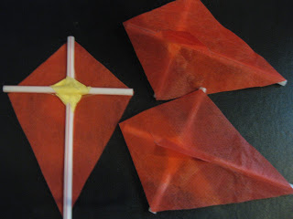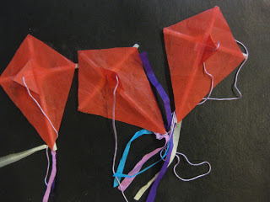
Decorate and add ribbon and string.
This activity reminds us of the wind blowing.
Sometimes the Holy Spirit feels like a mighty wind.
Why not see if your kite can fly?

Make a windmill
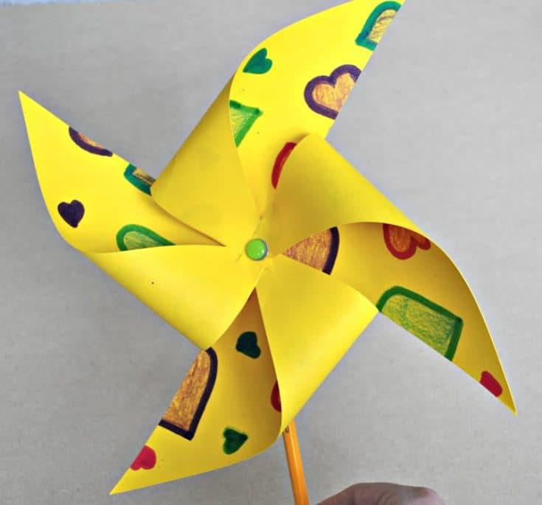
You will need :
A square piece of paper 6inches by 6 inches is a good size.
A split pin
A straw
Felt tips or pencils to colour
Decorate the paper on both sides.
Then fold the paper diagonally so that it makes a triangle.
Then do it the other way so that you have 4 triangles
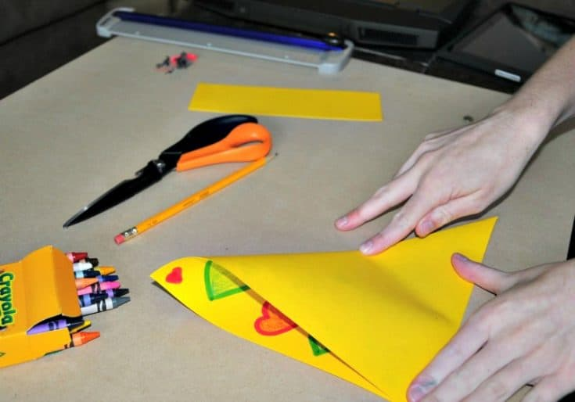
Cut along the creases about halfway to the middle of the paper. Be sure not to cut all the way.
Bend each corner into the middle. Make sure to bend and not fold 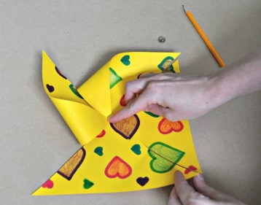once all 4 corners are in the middle push the push the split pin through them all as well as the straw Be careful not to hurt yourself with the pin!
Paper cup craft 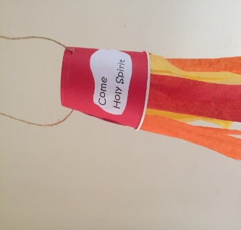
Take a paper cup. Red orange or yellow are best as these are the colours of flames and we are remembering the flames that came down on the disciples when the Holy Spirit came. Alternatively colour the cup.
Print out the template for the dove which is attached.
Cut out the template and words and stick them on the cup.
Or draw your own
Using red, yellow or orange tissue paper make some tassels to attach to the top of the cup (remember the cup is upside down- see image)
Make a hole on both side on what would be the base of the cup and thread some string through. Tie a knot.
Your Holy Spirit cup is now finished. 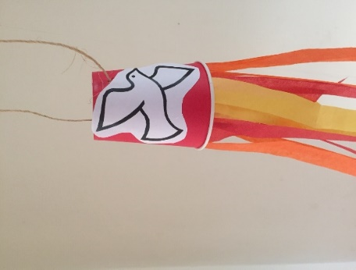
And finally,
As we are celebrating the birthday of the church perhaps you would like to make a cake or buy one and place a birthday candle in it.
Happy Pentecost

