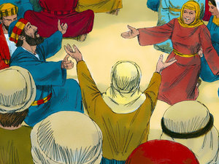
The Story of Pentecost
All the disciples and other friends of Jesus gathered in a big room in Jerusalem and waited for the Holy Spirit just as Jesus had told them to.
They enjoyed each other's company and had meals together. They discussed the things Jesus had told them while He was with them. And most importantly, they prayed together.
It was during one of these prayer meetings that strange and wonderful event occurred.
SUDDENLY, from out of nowhere, came the sound of a rushing mighty wind. It sounded like a huge tornado was right in the room with them!
And that isn't all . . .
They saw something that looked like two flames of fire resting just above each person's head!
And that still isn't all . . .
They were all filled with the Holy Spirit, and they all began to speak in other languages which they had never learned!
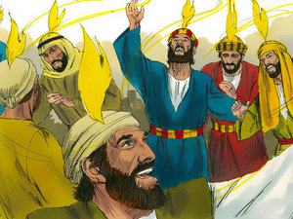
The noise from the wind, and from the praying, and from all the people speaking at the same time was so loud that people outside on the street down below were beginning to wonder what in the world was happening up there in that room!
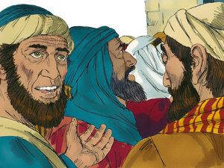
People came from all around to find out what all the commotion was about. They were amazed and thought it was marvelous that they were hearing people speaking in their own language, because they knew that the people in the room were all from Galilee and didn't know any other language except their own.
Some people were thrilled to be hearing about the wonderful works of God. Other people didn't understand and thought the people in the room were just drunk.
Peter stood up and started to preach to all the people standing outside. He explained that no one in the room was drunk and that what they were seeing and hearing was the power of the Holy Spirit.
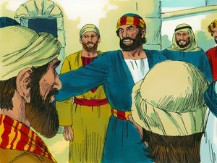
He preached to them about some of the prophecies in the Old Testament.
He preached to them about the teachings of Jesus.
He preached that Jesus was truly the Son of God and they needed to accept Him.
He preached that they needed to repent of their sins and be baptized.
And he preached that if they turned away from their sins and accepted Jesus Christ, they too could receive the gift of the Holy Spirit.

On that ONE DAY, THREE THOUSAND PEOPLE became believers in Jesus! HALLELUJAH!
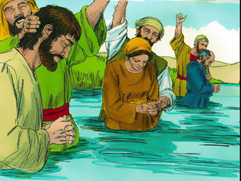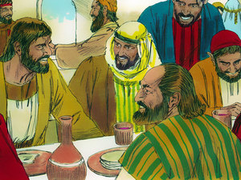
They continued to meet together for meals, fellowship, and prayer, and many other amazing miracles were done through the power of the Holy Spirit.

The Day of Pentecost is the birthday of the Church.
‘Happy Birthday Church’

THINK!
1. Why did Jesus' friends stay in Jerusalem?
2. What were the three signs of the Holy Spirit?
3. Who can receive the gift of the Holy Spirit?

