Activities – (attached)
1 Story: Jesus’ Ascension

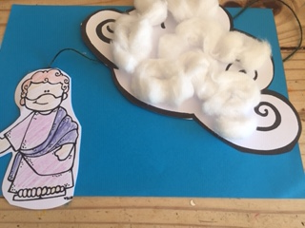
2 Wordsearch

3 Cloud template and Jesus template
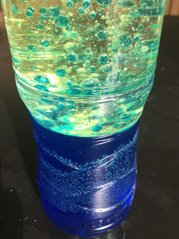

4 Ascension bubbles science experiment
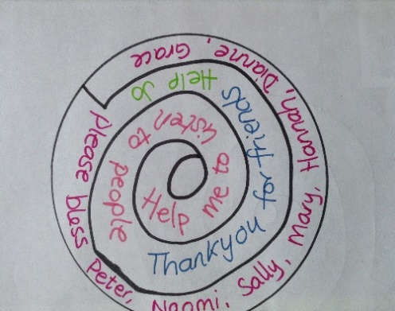

5 Ascension spiral
prayers

6 Colouring

7 Megaphone template - print out or make your own, decorate and colour
Remember that Jesus told his friends to tell everyone about him.
Who could you tell?

Crafts
Re-tell the story of Jesus ascending into heaven using the following craft
You will need:
A paper cup, scissors, string, blue and white paper, colouring pencils, a lolly stick or any stick.
Take a paper cup and cut a hole in the base.
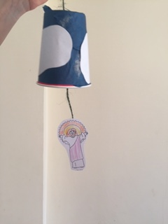
Decorate the cup with blue and white tissue paper or any paper you have (this represents the sky and the clouds.
Draw and cut out a figure to represent Jesus.
Colour this in.
Thread the string through the hole in the base. Wind the string around the stick.
Attach the other end using selotape to the figure of Jesus.
You can now re-tell the story.
As Jesus ascends into heaven pull the figure up by winding the string.

