Easter 2
Here is our second session on Easter. In this session we will be thinking about Jesus last meal with his disciples, praying in the Garden of Gethsemane, His arrest and his death. Whilst also remembering that this is not the end of the story.
Included
Story for children (Bubbles bonus M)
The Last supper
Talking to God
Scribble around
A Fair trial
Easter booklet
Easter craft

Craft ideas
Here are some craft ideas that you can make using things you have at home.
- Make a cross out of playdough (recipe at the end)
And decorate with twigs, stones, beads or buttons
Think about how Jesus died on the cross so that we could be forgiven for the things we do wrong.
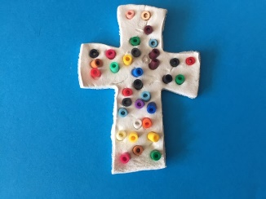

- Make some handcuffs out of paper
Imagine how Jesus must have felt when he was arrested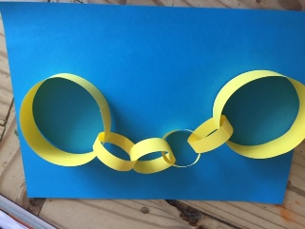
3.Gather together things to retell the Easter story.
You can use Lego people or make peg people for the characters
You can use paper to make palm leaves for Palm Sunday
Use some bricks to make a table for the Last supper and put 13 figures around it (Jesus was there with his 12 special friends).
Make flowers and gather some twigs and leaves for the Garden of Gethsemane.
Use some Lego or blocks of woods to make the court for the trial of Jesus Use a cross or make one from twigs or sticks to remind us Jesus died.
Then flowers for the garden where Jesus body was put with a flowerpot as a tomb or an egg box using just one egg holder and a stone rolled away
This is what I did 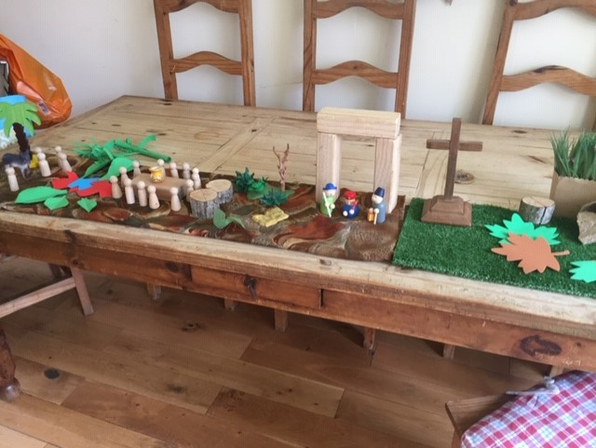

To think about:
When Jesus had his Last Supper with his friends he broke some bread and said ‘this is my body broken for you’
Then, he drank some wine and said ‘This is my blood shed for you’.
What do you think Jesus meant when he said this?
Jesus went to the Garden of Gethsemane to pray.
He asked three of his disciples who were with him Peter, James and Jokn,to stay awake but they couldn’t and they fell asleep.
How do you think Jesus felt?

One of Jesus friends betrayed him to people who didn’t like Jesus and he was arrested even though he had done nothing wrong.
Have you ever had a time when you were treated unfairly? (maybe put on the handcuffs if you have made them and imagine how Jesus felt).

Jesus was crucified on a cross on Good Friday.
That may not seem good to us.
But because Jesus died all the things we do wrong are forgiven by God and we can be friends with him.

On Easter Sunday we will celebrate that Jesus came back to life again.
How amazing!
But we will look at that in our final session on the Easter Story.

Playdough recipe
1 cup flour (if you can get it!)
½ cup salt
2 teaspoons cream of tartar
1 cup water
2 tablespoons oil
Food colouring
· Combine flour, salt and tartar in pan
· Gradually stir in water mixed with oil and colouring
· Keep mixing and stirring on medium heat until mixture becomes dry
· Remove from heat allow to cool and knead well
Enjoy the activities!

